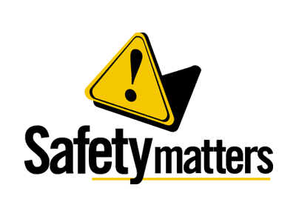 | Safety Tidbits
May 13, 2013 Silence heals; silence soothes; silence comforts; silence purifies; silence revitalizes us. -J.P. Vaswani
Choking Hazards  For small children, choking hazards include foods like hot dogs, popcorn, hard candy, peanut butter, ice cubes, cheese cubes, whole grapes, raw vegetables, fruits with skins.  Since children put just about everything in their mouths, many household items and toys are choking hazard as well, including balloons, coins, marbles, small balls, crayons, rings, ornaments and lights. Be aware of other choking hazards that may harm your children.  US ARMED FORCES Strong and Resilient  Prepared To Meet Any Challenge  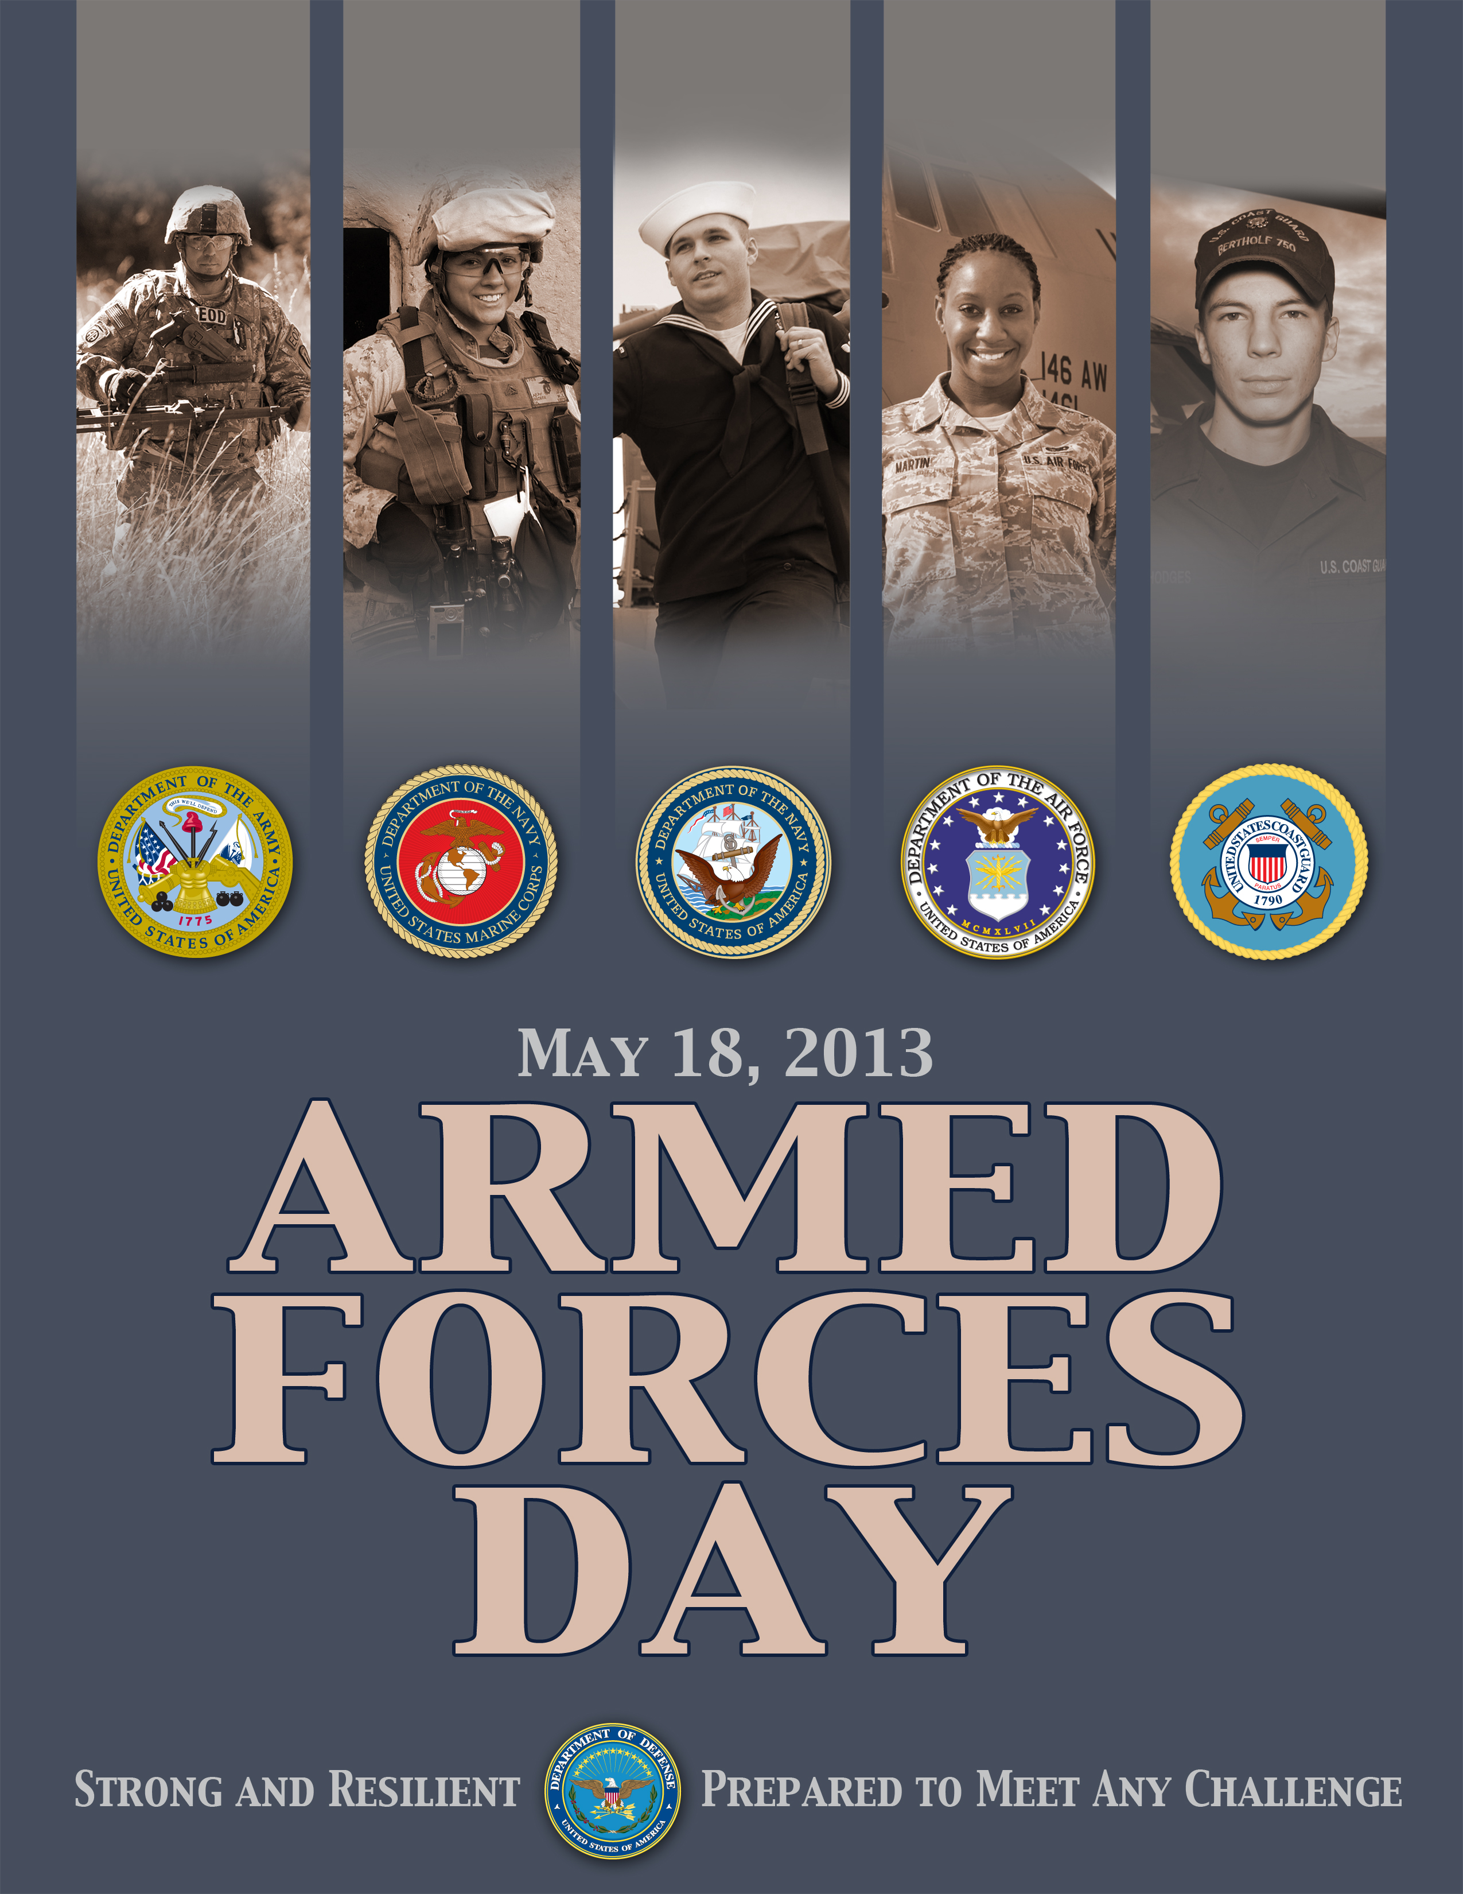  Knock, knock  Who’s There?  Barbie  Barbie Who?  Barbie Q Chicken  Who is the greatest underwater spy?  POND…  James POND! | Choking is an Emergency  Treat every choking instance as an emergency. If you witness someone choking, call 9-1-1 immediately. If you are familiar with life saving techniques, such as abdominal thrusts, use them to try to clear the airway. Do not attempt to drive a choking person to the hospital emergency room yourself unless the 9-1-1 operator instructs you to.  If you are alone and choking, and you can’t speak, dial 9-1-1 and leave the phone off the hook. In most communities, emergency personnel automatically respond to 9-1-1 calls in which the caller does not speak. While waiting for the emergency crew to arrive, you can attempt to clear your airway by thrusting your mid-abdomen (the area at the bottom of your ribs) against a chair back or railing.  Common causes of choking in older adults:  ▪ Eating too fast or trying to swallow large pieces of food;  ▪ Walking, talking or laughing with food in the mouth;  ▪ Drinking alcohol before or during meals;  ▪ Wearing dentures; and  ▪ Eating foods that are the wrong texture if you are on a special diet.  Signs that someone could be choking: Coughing or gagging; Sudden inability to talk; Turning blue around the face & lips; Passing out; and. Clutching at or pointing to the throat  Sun Safety  One in five Americans will develop skin cancer, so childhood education about sun safety is a vital step toward reducing risk and improving public health. About 23% of lifetime sun exposure occurs before the age of 18. Overexposure to the sun's ultraviolet (UV) rays seriously threatens human health. Besides the immediate effect of sunburn, over time excess UV radiation can cause skin cancer, eye damage, immune system suppression, and premature aging. Learning about sun safety and dangers of sunbeds is the key to reducing the risk of future health problems.  The purpose of life is to discover your gift. The meaning of life is to give that gift away and share it with the rest of the world. -David Viscott  Non-union Employees may select anyone as representative, says OSHA  On April 5, 2013, the federal Occupational Safety and Health Administration (“OSHA”) released an interpretation letter stating that during its inspections of nonunion workplaces, employees can be represented by anyone authorized by the site’s workers.  The letter from Richard Fairfax, Deputy Assistant Secretary of OSHA, mentions that OSHA standard 29 C.F.R. §1903.8(c), Representatives of Employers and Employees, allows workers at establishments without collective bargaining agreements to designate who will act on their behalf during inspections and it does not have to be an employee, according to Fairfax.  Remember our Military Personnel on Armed Forces Day  President Harry S. Truman led the effort to establish a single holiday for citizens to come together and thank our military members for their patriotic service in support of our country.  On August 31, 1949, Secretary of Defense Louis Johnson announced the creation of an Armed Forces Day to replace separate Army, Navy, Marine Corps and Air Force Days.
Compliance + Integrity = Safety Excellence

