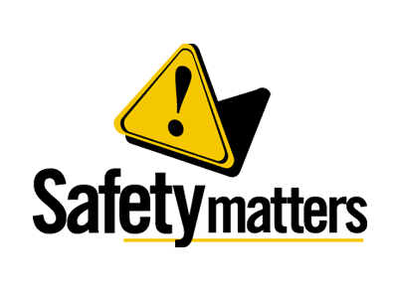 | Safety Tidbits
March 25, 2013 What we see depends mainly on what we look for. - John Lubbock
Kidney Disease Facts:  • Kidney disease is the 9th leading cause of death in the country.  • More than 26 million Americans have kidney disease, and most don’t know it.  • African Americans are three times more likely to have kidney failure than whites.  • More than 590,000 people have kidney failure in the U.S. today.  • There are over 95,000 people waiting for kidney transplants.  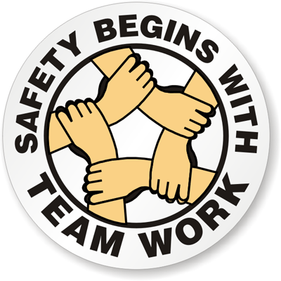  Why did the skeleton go to the BBQ?  To get ribs!  Why did the TV cross the road?  Because it wanted to be a flat screen.  No great man ever complains of want of opportunities.  -Ralph Waldo Emerson |  | The Power of Responsibility  by Michael Josephson (posted by Bryan Haywood on Safteng.net)  It's been said that the line between childhood and adulthood is crossed when we move from saying 'It got lost' to 'I lost it.' Indeed, being accountable - understanding and accepting the role our choices play in the things that happen - are crucial signs of emotional and moral maturity. That's why responsibility is one of the main pillars of good character. Many people have been seduced by the Peter Pan philosophy of refusing to grow up and avoiding the burdens implied in being accountable.  Yes, responsibility sometimes requires us to do things that are unpleasant or even frightening. It asks us to carry our own weight, prepare and set goals, and exercise the discipline to reach our aspirations. But the benefits of accepting responsibility far outweigh the short-lived advantages of refusing to do so. No one makes his or her life better by avoiding responsibility. In fact, irresponsibility is a form of self-imposed servitude -to circumstances and to other people. Responsibility is about our ability to respond to circumstances and to choose the attitudes, actions, and reactions that shape our lives. It is a concept of power that puts us in the driver's seat. The grand panorama of the potential of our lives can only be appreciated when we begin to be accountable and self-reliant.  Responsible people not only depend on themselves, but show others that they can be depended on. This breeds trust, and trust is a key that opens many doors.  If we want more control over our lives and the pleasures, prerogatives, and power of freedom and independence, all we have to do is be responsible.  The most common cycling accidents involve colliding with a car or another bicycle, loss of control, entangling hands, feet, or clothing in the bicycle, or feet slipping off the pedals. Bicycle riders of all age groups and levels of experience need to be concerned about safety.Studies have shown that wearing a bicycle helmet can reduce head injuries by 95 %.  Fire Safety Facts  • A fire occurs in a home fire occurs every 85 seconds.  • Nationwide, there was a civilian fire death every 175 minutes, and a civilian death in home fires occurred every 208 minutes.  • Nationwide, there was a civilian fire injury every 30 minutes, and a civilian fire injury in home fires every 38 minutes.  • Almost two-thirds (64%) of home fire deaths resulted from fires in one of three areas: ◦ the bedroom ◦ the living room, family room or den ◦ the kitchen  • Children under 14 account for 20% of the population and 15% of the fire deaths.  • Although adults between 20 and 64 are not at high risk of fire death, these adults account for half (52%) of such fatalities.  • From 2006-2010, children under five were 1.2 times as likely to die in a home fire as the general population.  If you have young children in the home you need a plan, conduct escape drills and have a designated meeting area. Tell the kids to act when the alarm sounds (not when it goes off… when it sounds it is really going ON!)
Compliance + Integrity = Safety Excellence!

