PLUMBER OF THE YEAR FINALISTS
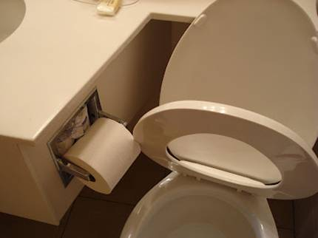

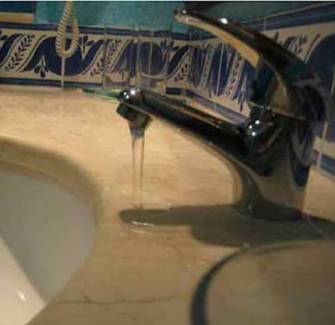
Hmmmmm...
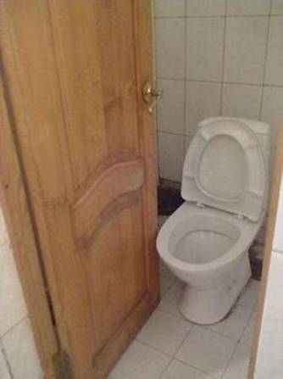
Should have measured twice!
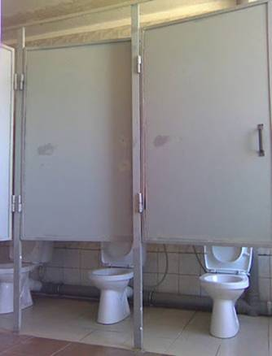
Apparently, you don't want anyone seeing your face, but everything else is okay?
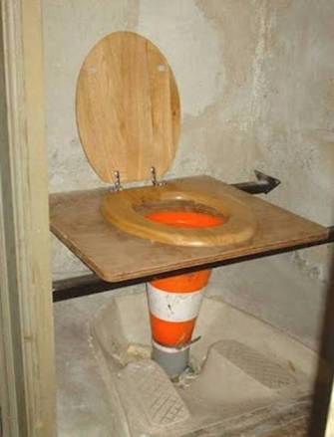
The oak seat is a nice touch, though.
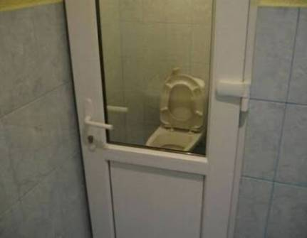
And the purpose for the door is?
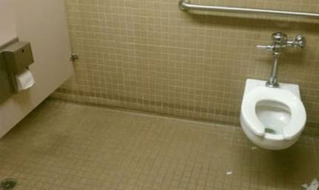
This stall is for people that have arms
like an orangutan.
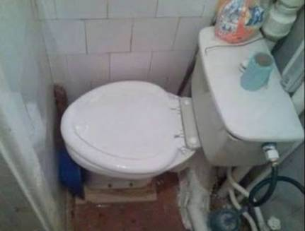
This would be the "half bath" noted in the real estate listing?
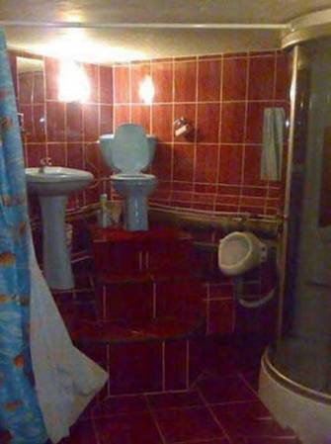
Very Classy! And, only three steps to the throne when you're in a hurry!
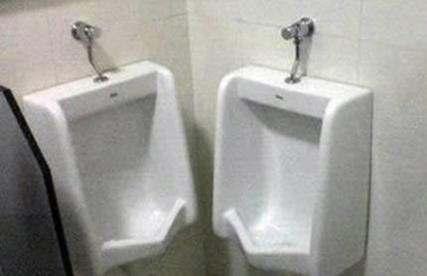
How does this even get past the planning phase?
And now drum roll please...
AND THE PLUMBER OF THE YEAR AWARD
GOES TO...
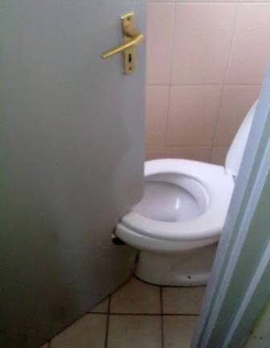
Absolutely brilliant...
ALL OF THESE PLUMBERS ARE, THANKFULLY, NO LONGER IN THE BUSINESS. THEY'VE BEEN ELECTED TO PUBLIC OFFICE AND NOW SERVE IN VARIOUS GOVERNMENT POSITIONS.

