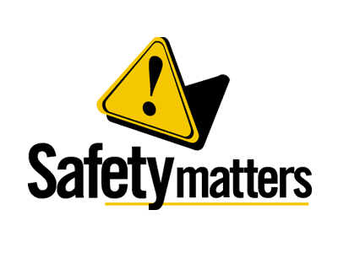 | Safety Tidbits
February 4, 2013 | You miss 100 percent of the shots you never take. –Wayne Gretzky
Cargill Cited for alleged LOTO Violations  OSHA cited Cargill Meat Solutions Corp. for failing to protect workers from unexpected start-up of machines at its Beardstown, IL processing facility. Proposed penalties total $114,000. OSHA initiated an inspection after receiving a complaint. The inspector wrote:  One willful violation - Directing workers to perform maintenance and servicing on carbon dioxide equipment without first documenting lockout/ tagout procedures designed to prevent unexpected energization.  One repeat violation - Failing to train workers who operate equipment on procedures to properly control hazardous energy. A similar violation was cited in May 2009 at the company's Nebraska City, Neb., facility.  One serious violation - Failing to document and certify periodic inspections of lockout procedures for older carbon dioxide equipment.  STEPS/Region 6 OSHA Safety Stand Down  In response to the recent rise in oil field operations fatal accidents, OSHA in partnership with the Region 6 STEPS Network is requesting Oil and Gas Exploration & Production companies participate in a voluntary safety stand down. The opportunity to participate in the Stand Down will continue until March 1, 2013. http://www.oshastanddown.org/StandDownAfterKickoff.pdf  Save on Dental and Other $ervices  Many of you are not aware that I come from royalty – between me, my wife, and my children, we have more crowns then Britain’s Royal Family. At around $1,200 a pop, they can get a guy thinking about dentures, especially when you see those ads Uppers & Lowers for only $299!  One way to save on services is to look for local schools in your area – students at dental, cosmetology and massage therapy schools offer their service at reduced rates. These students are usually near graduation and just need some final practice; with instructors available to assist as needed.  Vehicle Backing Accident Facts  Motor vehicle accidents are a leading cause of workplace fatalities. Each month, at least one worker dies from being backed over by a vehicle – in many cases the vehicle has an obstructed rear view. In such cases, the driver should always use a spotter. Too many times, ground personnel walk behind moving vehicles or equipment assuming they can be seen by the operator. Fact is equipment blind spots can be huge.  Be careful and alert in office, mall, church & school parking lots – if walkways/crosswalks are provided USE THEM and pay attention to your surroundings. Annually, there are on average 463 fatalities and 48,000 injuries, (6,000 of these incapacitating), as a result of backing crashes. Children under age 5 and elderly people are most likely to be killed in a back-over crash. If you have young children or in the neighborhood it is always a good idea to walk around the vehicle before backing out of a driveway. Source: NHTSA |  | Ergonomics Reminder  Remember: EARLY INTERVENTION is the key to reducing your risk of permanent damage. Beware of these signs and symptoms:  -Pain in the fingers, wrists, or other parts of the body: may include a dull aching pain, a sharp stabbing pain, or even a burning sensation  -Tingling or numbness, particularly in the hands or fingers  -Swelling, inflammation, or joint stiffness  -Loss of muscle function or weakness  -Discomfort or pain in the shoulders, neck, or upper or lower back  -Extremities turning white or feeling unusually cold  -General feeling of muscle tightness, cramping, or discomfort  -Clumsiness or loss of coordination  -Range of motion loss  -Discomfort when making certain movements  ______________________    Lighten Up  1.) What do you call a duck that steals? A Robber Duckie!  2.) What do you call a hippy’s wife? Mississippi!
Compliance + Integrity = Safety Excellence!

