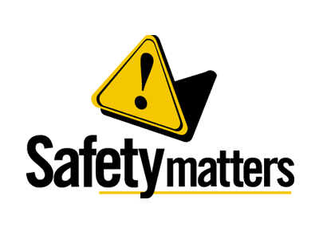 | Safety Tidbits
February 11, 2013
Did you know…  -Prepackaged microwavable soups are a frequent cause of scald burn injuries (especially noodle soups) because they can easily tip over, pouring hot liquid (and noodles) on the person.  -Many toddlers are subjected to scalding burns because of hot bath water. Always check the water before putting the kiddies in it!  -Forget McDonalds, Panera Bread has the hottest coffee I’ve ever come across. And I mean Ha, ha, ha, ha HOT!!!…I didn’t realize how hot until I got it all over my light tan pants! No sir… there was nothing funny about it. Remember that old tune Splish, Splash? Anyway be careful when you pick up that morning coffee. If you spill it… it could leave a mark!  Don’t forget… Valentine’s Day is Thursday!!! | February is National Heart Month  Cardiovascular disease is the leading cause of death in the United States; one in every three deaths is from heart disease or stroke, equal to 2,200 deaths per day. As a nationwide push to raise heart disease awareness, February is American Heart Month and it is sponsored annually by the American Heart Association.  Heart disease strikes both men and women, but the disease in women is underappreciated by the general population, and with serious consequences. In fact, heart disease is the number one killer of women. According to the National Heart, Lung and Blood Institute, one in four women die from heart disease, while one in 30 women die from breast cancer. Heart disease accounts for more deaths in women than all cancers combined  Ergonomics Tip  -Keep your feet flat on the floor. If your feet don’t reach, adjust your chair or use a footrest.  -Position your computer monitor so that your eyes are level with the top of the screen (oversize monitors are exceptions). The center should be at 15 degrees below your line of sight and approximately an arm’s length away. Raise or lower it as necessary.  -If you wear bifocals, check with your therapist about lowering your monitor to avoid crooking your neck.  -Use a document holder to raise materials to eye level, rather than bending your neck toward the desk.  Beware of Machinery and Equipment  A worker's arm was severely injured at the Yukon Flour Mill. Employees were loading a tractor-trailer with canola grain when the man's clothing became caught in a conveyor in the basement of the mill. Ensure machine guarding is sufficient and maintained in good condition  St. Valentine’s Day Massacre  On a frigid morning, in an unheated brick garage, seven men were lined up against a wall and pumped with 90 bullets from submachine guns, shotguns and a revolver. It was the most infamous of all gangland slayings in America, and it achieved its purpose--the elimination of Al Capone’s last challenger for the title of crime boss in Chicago. By 1929, Capone's only real threat was George "Bugs" Moran, who headed his own gang. Moran had long despised Capone, mockingly referring to him as "The Beast."  At about 10:30 a.m., four men burst into the SMC Cartage Co. garage that Moran used for his illegal business. Two of them were dressed as police officers. The quartet announced a raid and ordered the Moran’s men to line up against a wall. Then they opened fire. Witnesses, hearing submachine gun fire, watched as the gunmen sped off in a black Cadillac touring car that looked like the kind police used, complete with siren. Capone's prize, Moran wasn’t there -he slept in.  Jokeline  What do you call a blind dinosaur? A Doyouthinkhesaurus.  What do yo call a snake that works for the government? A civil serpent
Compliance + Integrity = Safety Excellence!

