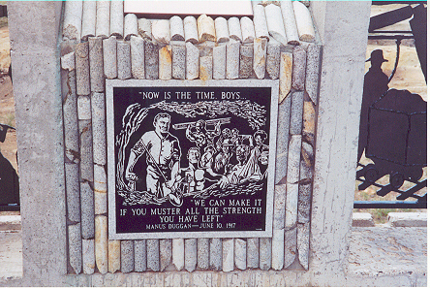

Mining was and still is a dangerous occupation. Many a good man has gone down into the womb of the earth in pursuit of ore never to return alive to the surface. "Missed holes" or dynamite charges that failed to go off, slabs of rock weighing tons teetering on the verge of collapse, fire and aliments of the lungs and body brought on by dust were some of the dangers of the mines. Butte had its share of disasters through the years. Butte first major mining calamity occurred on November 23rd, 1889. Fire broke out in the shaft of the Anaconda mine, sending smoke and gas through the workings. Fortunately, the fire occurred between shifts with most of the miners out of the workings. Only 6 were killed and 2 were badly injured.

The years 1915-1917 were witness to three devastating disasters in camp history climaxing with the Speculator Fire of 1917. On October 19th, 1915, 16 shift bosses and assistant foremen on surface for their lunch hour were grouped around the shaft of the Granite Mountain Mine awaiting the 12:30 whistle to announce the time for lowering the mine cage to take them down to their work. Beside them on the surface turn sheets a small hand truck with 12 cases of fourty percent dynamite waiting to be lowered as well.
At the first blast of the whistle, for whatever cause, the 12 boxes of explosives exploded with such fury, the sound of it was heard for miles. The 16 men standing around were blown to bits. Fingers with rings were found miles away from the scene of the accident. Undertakers scoured for miles, searching for pieces which in turn were placed in one sealed casket. A combined funeral was held.
Early the following year, fire broke out in the workings of the Pennsylvania Mine. Fortunately it was undergoing repairs at the time and no great number of men was working. Twenty, of the forty or so in the mine at the time, fell victim to the deadly gas. Once again Butte mourned and combined funeral services were held with the entire city in attendance.
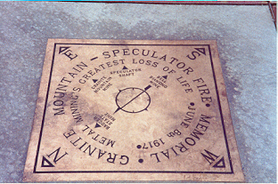

The United States had been at war for over two months on the night of June 8th, 1917. War industries were clamoring for copper. Every mine in Butte was working at full capacity. Among them was the big Speculator, with close to 2,000 miners employed on two shifts.
Oddly, it was the Speculator where "Safety First" had been stressed the hardest. A crew of safety engineers was employed. All modern safety improvements and practices had been installed and motion pictures showing safety methods were periodically shown to the workers. Attendance was compulsory.
But on that June evening, the night shift of some 900 men had been lowered and were at work. During the late afternoon and evening, ropemen and shaftmen had been lowering a huge, insulated electric cable to operate the ventilation fans on the lower level. The heavy cable had somehow become fouled and was hanging suspended in the shaft. For some time the workers had been vainly trying to free it. The assistant foreman on the night shift had descended to aid in the difficulty. The cable was an old one with the insulation in some places frayed and worn. Sallau, the assistant foreman, his carbide lamp in hand, was examining it in the endeavor to find some way to break the tangle and getting it started down the shaft once more. In some inexplicable manner, his carbide light came in contact with the frayed edge of the insulation.
Like a light match thrown into gasoline, the insulation burst into flames. Acting as a chimney, the drafts in the up-cast shaft pulled the flames toward the surface and in an instant; the entire length of the cable was ablaze. As the dry shaft timber caught fire, it was but a moment before the entire 3000 feet of shaft had been turned into an inferno.

At the first flash, Sallau and his assistants hurriedly descended out of danger, below the path of the flames. But by now, the damage was done. Any effort on their part to prevent the spread of the flames would have lead to nothing but their cremation. It was but a few moments before the flames were shooting out of the mouth of the shaft on the surface, consuming with incalculable speed the dry timbers and sending the deadly gas and smoke to every level. An instant before the cable was ignited; two station tenders were lowered into the mine. Hardly had it disappeared from the surface then the flames shot out of the shaft. When the torched cage was brought back up, all was found was some charred bones and buttons from the two men’s' overalls. Underground at every level, the scene was the same. Many of the miners, smelling the first whiff of smoke, had made a run for it and escaped through levels of other mines adjoining the Speculator. These men were quickly hoisted out from these other mines.
An hour later, after the fire had burned itself out, an attempt was made to enter. Over a dozen volunteers were loaded on the mine cage, among them the man whose lamp had inadvertently caused the fire Sallau. As the cage reached its destination and the rescuers stepped off, they were met by a blast of the deadly gas and all perished on the turn sheets of the stations. All other attempts for rescue were abandoned until fresh air could be pumped into the mine.
Butte was shocked and stunned. A check of the survivors showed that over 200 miners were still left down below. Barring a miracle, the survivors said that they had seen the drifts and stations strewn with the dead. The mine yard was chaos, the hospital filled with the injured. Two days and a night had passed since the flames first started and fresh air was being pumped into the mine. All hope for anyone being alive was lost. All that remained was to bring up the dead. It was then that a small miracle happened. Sitting in his chair in the engine room, the engineer of the Speculator was astonished to hear a signal flash from the depths where moments before he was sure there was no living soul. Somehow, someone had escaped the deadly gas.
Another signal, he lowered the cage to where the signal was coming from and then raised the cage back up. Before the astonished on look of hundreds of eyes who crowded around the shaft, nine men, blackened, haggard but alive stepped from the cage into the sunlight and bringing news that 16 more were waiting down below alive waiting to be hoisted above. Down the shaft again went the cage and back again, until in all, 25 miners had been brought up from the dead into the sunlight of the mine yard.
The 25 men owed their lives to the brave act of one man, a 25 year old miner named Manus Duggan. Within an hour after the fire had started, Duggan marshaled a group of 29 men and gathered them together in cross cut into which the deadly gas had yet penetrated. Hastily erecting a bulk head of timbers, canvas, clothing and dirt, he took charge of the little group of men in the small cramped cross cut, keeping up their morale and preventing them from making the break for a supposed safety that would have surely meant their doom. As tiny apertures appeared, Duggan forced them to strip their clothing from their bodies to plug up the gaps and keep out the gas. As the long hours passed, breathing became more and more difficult. When Duggan saw at last that it was only a matter of minutes before they all would succumb, he decided to seek a path to safety for his charges. Taking three of the men, he set out to find a path to safety through some other mine then coming back for the rest. Manus Duggan and the three followers never returned. Days later, their blackened bodies were discovered in a drift where they had fallen.
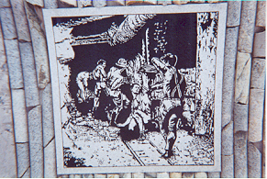A memorial to this disaster now overlooks Butte. It is also dedicated to all miners. Bricks have been laid out at the memorial and each one has an inscription by people who have bought a brick. In between the bricks are concrete spacers and blocks of core samples from the mines. The cement pillars are adorned with engraved plaques that interpret and commemorate the loss of life and the heroic efforts of victims to escape the fire and smoke and of their fellow workers who struggled against time to save as many lives as they did. Here you can read more about Duggan and other stories of heroism.



