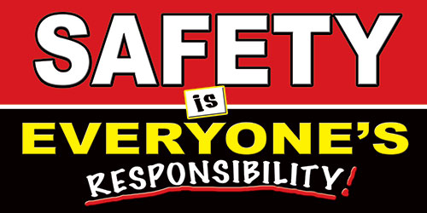 | Safety Tidbits
10-27-14 The results you achieve will be in direct proportion to the effort you apply. -Denis Waitley
  Trick or Treating Tips:  • A parent or responsible adult should always accompany young children on their neighborhood rounds.  • Only go to homes with a porch light on & never enter a home or car for a treat.  • Stay in a group and communicate where they will be going.  • Remember reflective tape for costumes and trick-or-treat bags.  • Remain on well-lit streets and always use the sidewalk.  • If no sidewalk is available, walk at the far edge of the roadway facing traffic.  • Use caution when crossing streets. Never assume the right of way. Motorists may have trouble seeing Trick-or-Treaters. Just because one car stops, doesn't mean others will.  What does a pig put on a cut? Oinkment  ☺ Life is good! | Tips for the Cooler Fall Weather  Dress in Layers! So you can add or remove clothes easily as needed. The layer closest to the skin should be synthetic as this material pulls moisture (sweat) away from the body.  Keep your head covered! You can lose up to 40% of your body head through your head. A face mask or scarf are also a good idea for when it is really cold outdoors.  Protect ears, hands and feet! Frost bite affects these areas first, so protect extremities when working, playing outdoors. You can lose about 30% of your body heat from your hands and feet.  Stay hydrated. Take time to intake water and other fluids. You still can lose fluids by sweating when working outdoors and cold weather also has a drying with a heated water dish, and an appropriate shelter. Most breeds are not made to handle the elements, unprotected.  Taking a Road Trip? Pack blankets, a car charger for your cell, snacks, flashlight, extra cold weather gear, a candle and matches – to melt snow, etc. and effect, which can increase the risk of dehydration.  Halloween Tips - ALL DRESSED UP:  • Plan costumes that are bright and reflective. Make sure that shoes fit well and that costumes are short enough to prevent tripping, entanglement or contact with flame.  • Consider adding reflective tape or striping to costumes and trick-or-treat bags for greater visibility.  • Because masks can limit or block eyesight, consider non-toxic makeup and decorative hats as safer alternatives. Hats should fit properly to prevent them from sliding over eyes.  • When shopping for costumes, wigs and accessories look for and purchase those with a label clearly indicating they are flame resistant.  • If a sword, cane, or stick is a part of your child's costume, make sure it is not sharp or too long. A child may be easily hurt by these accessories if he stumbles or trips.  • Obtain flashlights with fresh batteries for all children and their escorts.  • Teach children how to call 9-1-1 if they have an emergency or become lost.  Fall Clean-up and Winter Prep Tips:  Use Caution on Ladders - Wearing appropriate footwear is important when using a ladder; shoes or boots may be wet, causing you to slip as you climb the ladder. The ladder should be positioned on a flat surface before use. Be sure that the tools you are using are specifically designed for this purpose and are in good condition before starting work.  Look Up Before Pruning Trees - If you have decided that your yard needs to be spruced up by trimming your trees, be sure to look up and survey the area carefully before you start. Make careful note of where power lines are located before you set up your ladder so that it is positioned away from them.  Clean Up Fallen Leaves - Keep your driveway and walkway clear of falling leaves. Wet leaves can create a hazard for pedestrians in the fall by making sidewalks slippery. Later in the season, snow may mix with leaves to increase the risk of falling.
Confused? – Never Assume! Stop – Think – ASK!!!

