Texas snakes are out in force this time of year. Usually if you leave them alone they will do likewise, so watch where you step.
The venomous varieties can be grouped into four basic categories: coral snakes, copperheads, cottonmouths (also known as water moccasins), and rattlesnakes.
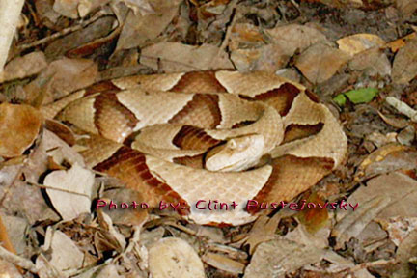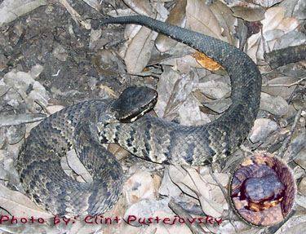

Copperhead Cottonmouth/ Water Moccasins

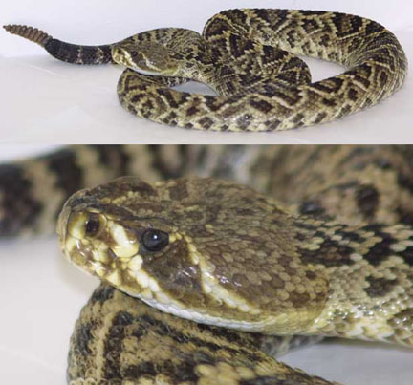
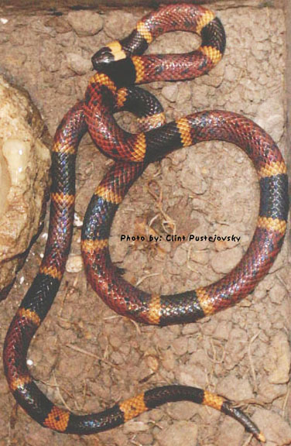
Rattlesnake/Western Diamondback Coral snake

