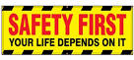 | Safety Tidbits
8-25-14 Keep Swinging! ‘Every strike brings me closer to that next home run.’ -Babe Ruth
Stand up & Speak out for Safety!  You’d Stop this guy, right?    So why not this guy?  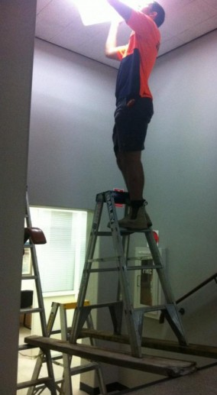  If you see an at-risk behavior, please speak up to help keep team members SAFE!  Keep it POSITIVE!  Be polite, let the co-worker know you care about their safety & ask if they are aware of the hazard! Then help them address the issue.  And, correct or report any unsafe conditions you find in the workplace!  _____________________  Did you hear about the guy who went dancing in a seafood disco?  Apparently, he pulled a mussel! | Always Check Your Path – even when doing overhead work!  A 31 year old contractor fell to his death from a catwalk at a Tampa Electric Co. power. The worker fell 40-50 feet through a metal grate on the catwalk in the 1:15 p.m. accident at the Bayside Power Station, he died at the scene. A TECO spokeswoman said the plant had been converted from coal to natural gas power generation, and workers were dismantling an old boiler that was no longer needed.  The facility was the scene of a generator explosion on April 8, 1999, that killed three workers and injured 50. TECO officials blamed employee errors for the blast, which was caused by hydrogen gas that had not been drained from a generator down for maintenance. The federal government blamed TECO and fined the company $25,200.  Majority Supports ‘No Texting while Driving’ Enforcement  New findings from a National Safety Council poll indicate that 73% of respondents think there should be more enforcement of texting laws, 22% said the current level of enforcement is fine.  When asked what type of penalties they’d like to see, 52% of participants chose penalties including a point system that could lead to the loss of a driver's license or increased insurance costs; 51% were in favor of different levels of penalties for first vs. repeat offenses and half thought large monetary fines should be used.  Currently, no state has passed a law banning all cell phone use while driving. Currently 44 states plus the District of Columbia ban texting for all drivers, and 13 states and the District of Columbia have laws banning handheld driver cell phone use.  Contrary to popular belief, the brain does not truly multi-task. More than 30 studies show hands-free devices are no safer than handheld as the brain remains distracted by the cell phone conversation. NSC estimates 26% of all crashes involve cell phone use while driving. Talking on a cell phone, either hands-free or handheld, is estimated be involved in 21% of crashes – with an additional 5% for texting. Help put an end to cell phone distracted driving with these tips:  • Make a personal commitment to drive cell free;  • Turn your phone off or put it on silent while driving so you are not tempted to answer it;  • Speak up when you are in the car with someone who uses a cell phone while driving – ask if you can do it for them, or if it can wait;  • Change your voicemail message to reflect that you are either away from your phone or driving, and that you’ll call back when you can do so safely;  • If you are talking to someone who you know is driving, tell them to call you back later.  Did you do a Hazard Assessment, today?  MATTYDALE, N.Y. - Officials suspect a welding torch ignited glycol fumes, causing a small explosion at an industrial facility, which burned a welder and knocked him from a ladder.  Mattydale Fire Department Chief Brian Falise described the injuries as "significant," though they did not appear life threatening. The man had been welding a large tank in one of the buildings housing Solvents & Petroleum Service on Brewerton Road, said company owner Phil Jakes-Johnson. He had been working as a contractor. The plant handles glycol - a key ingredient in antifreeze - which Jakes-Johnson said may have caused the small explosion. "This is my nightmare coming true," said Jakes-Johnson, adding that he was thankful the accident was not more severe. OSHA is investigating the incident. Make sure you understand the hazards associated with the task you are about to perform. Unsure? STOP, THINK and ASK!  Be aware of the Top Five!  Data from Liberty Mutual’s 2012 Workplace Safety Index listed the Top 5 leading causes of injuries for 2010. Here they are: Overexertion; Fall on same level; Bodily reaction (Injuries from bending, climbing, reaching, standing, sitting, slipping or tripping without falling) Falls to lower level; and Struck by object. What are you doing to ensure you don’t get injured on the job?
Actively Caring about other team members leads to Safety Excellence! Care enough to Speak up!

