NGO confirms the death of the 7 miners trapped by a landslide in Mexico
"Their painful deaths would have been avoided with real measures of non-repetition after Pasta de Conchos. Mining must stop being a destiny of death in the coal region," the organization said in another message.
By
The Rio Times
-
June 11, 2021
RIO DE JANEIRO, BRAZIL – The seven miners trapped by a landslide last Friday in the municipality of Múzquiz, in the Mexican state of Coahuila (north), died, reported Thursday the NGO Pasta de Conchos Family by confirming the death of the worker Juan Carlos Moreno.
“We regret the loss of our colleague Juan Carlos Moreno Cervantes. The State Attorney General’s Office (FGE) informed that his body has been recovered,” said the NGO, formed by relatives of the victims of the mining accident that occurred in Coahuila in 2006, in which more than 60 workers perished.
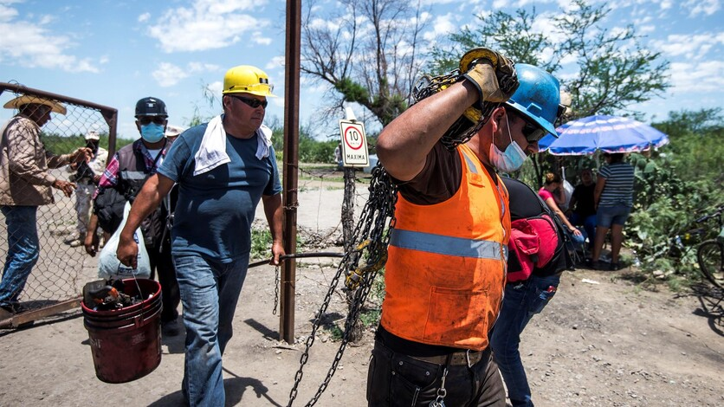NGO confirms the death of the 7 miners trapped by a landslide in Mexico
“To his family, friends, and colleagues our affection and to the rescuers our immense gratitude for their dedication and strength to leave no one behind,” the message added.
Moreno’s was a difficult case. Initially, he had been identified as the fifth miner, but he was handed over to the wrong family, a mistake recognized by the authorities, who later rectified that it belonged to the miner whose name was Damián Ernesto Arias.
On Wednesday night, the Attorney General’s Office reported the rescue of the sixth lifeless body, that of Leopoldo Méndez Sánchez.
According to the organization, the bodies recovered in previous days were those of the miners Mauricio Cortés, Humberto Rodríguez, Pedro Ramírez, and Gonzalo Alberto Cruz.
The recovery of the seven bodies occurred almost a week after the collapse on Friday, June 4.
“Their painful deaths would have been avoided with real measures of non-repetition after Pasta de Conchos. Mining must stop being a destiny of death in the coal region,” the organization said in another message.
Once it was known about the collapse, President Andrés Manuel López Obrador stated on his social networks that the National Guard and the Army had been sent to the site, and wished that the rescue would be “favorable for the families and for everyone”.
The hypothesis handled by the authorities is that a flood caused the rupture of the roof and walls of the mine, which generated the collapse of the place, inside which the seven miners were trapped.
In addition to the military, Civil Protection authorities and inspectors from the Ministry of Labor are working at the site to carry out the rescue work, which consists of pumping out the water to access the mine.
The accident was reminiscent of what happened in February 2006 at the Pasta de Conchos mine, also in Coahuila, where 65 workers died in an accident and only two bodies were recovered.
Since then, there have been more than 100 deaths of miners in the area, according to the Pasta de Conchos Family, a group of relatives of the victims of the tragedy.
On October 23 of last year, this group sent a letter to Manuel Bartlett, director of the Federal Electricity Commission (CFE), a state-owned company, complaining about the conditions of the Micaran mine in Múzquiz, which was involved in the accident on Friday.
However, the company distanced itself this Saturday from what happened and assured that the accident mine does not supply coal to the CFE and that, therefore, “it was impossible for its director (Bartlett) to be aware of the mine”.

