Near Miss Level 5 Significant Incident Alert

785 Haul Truck Drove Over Toyota Condor With 3 Occupants
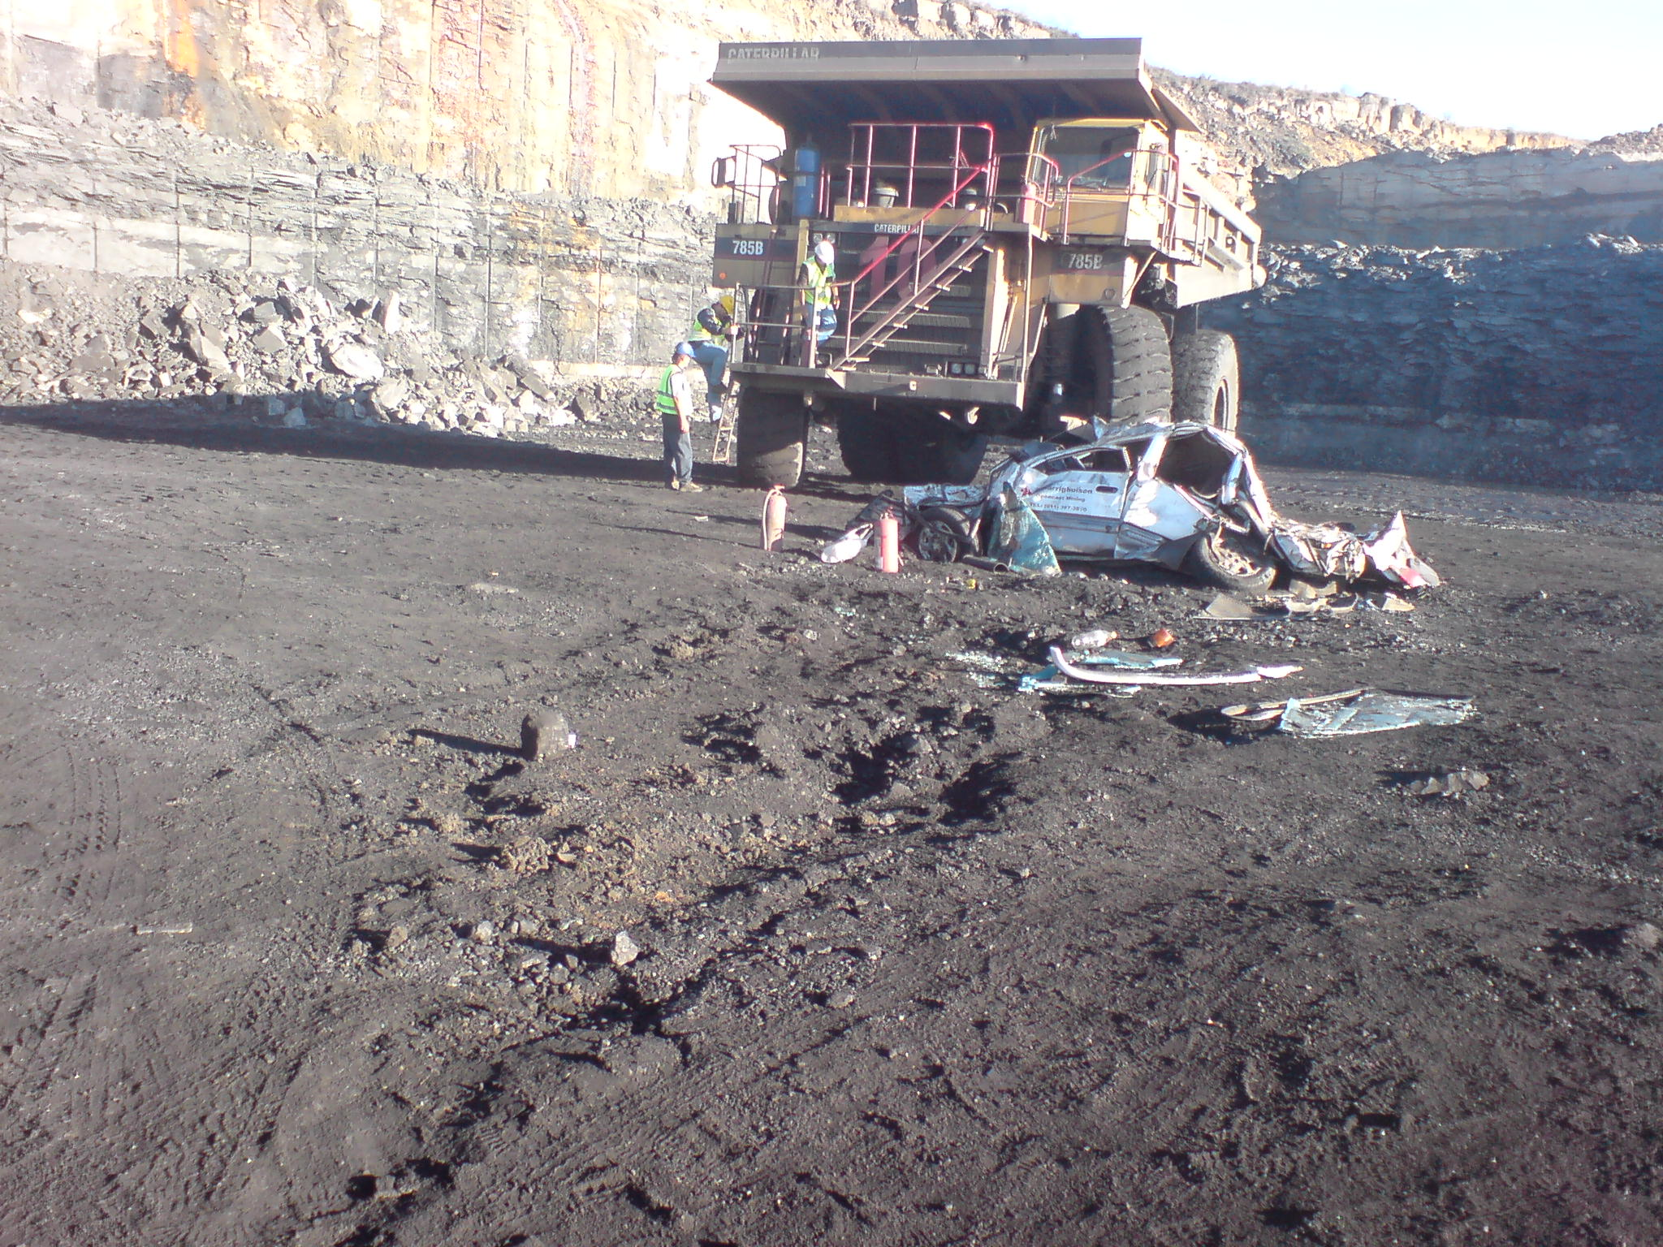
Brief Description
A shift supervisor, accompanied by two operators entered the 4 seam mid burden loading area at ramp 1 with his vehicle. Concurrently, loading operations were in progress. As the 785 haul truck moved forward and turned to his right, in the direction of the loader, the supervisor’s vehicle entered the path of the oncoming 785. The 785 operator only realised that he had driven over the supervisors vehicle once he was busy reversing into position to be loaded.

Injuries
Minor injuries to two of the Condor occupants.
The third occupant sustained a contused chest & contusion of heart.

Key Messages
- Positive communication and identification of vehicles in close vicinity to each other is critical
- Blind spots of Heavy Mobile Equipment interacting with Light Vehicles and persons must be considered
- Designated distances of Light Vehicles and heavy mobile equipment must be observed

Whilst this Significant Incident has only been released in Preliminary format, it is felt that the multiple fatalities that might have resulted merit a general and urgent sharing of the event.
Please ensure that all your personnel, including contractors are made aware of this incident and that all relevant site standards are reviewed.

