Coronavirus patients with heart disease have a 10% death rate. Here's the death rate for patients with various underlying health problems.
Older patients and people with preexisting health conditions more commonly develop severe symptoms from the new coronavirus, a recent study found.
The study, done by the Chinese Center for Disease Control and Prevention, found that the overall death rate of COVID-19 — the disease caused by the virus — is 2.3%. Other estimates suggest the death rate could be higher: around 4.3%. The current rate, based on the ratio of reported deaths to total cases worldwide, hovers around 3.4%.
But the Chinese CDC study found that the death rate rate rose to 8% for patients in their 70s and 15% among those in their 80s. Out of more than 44,000 coronavirus patients studied, the majority of deaths were among those at least 60 or older.
Older patients are also more likely to have preexisting health problems.
Nearly 5,300 patients in the Chinese study reported a health condition not related to the virus, such as cancer, heart disease, or diabetes. Around 7% of those cases — more than 370 patients — died. Overall, patients with preexisting conditions represented more than a third of all deaths reported in the study. The death rate for patients who reported no underlying health problem was less than 1%.
Here's the death rate for each preexisting condition reported in the study:
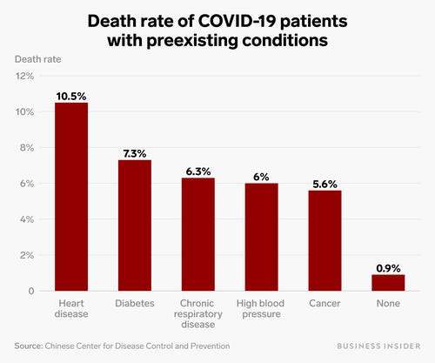
Ruobing Su/Business Insider
The authors were missing the health history of more than 20,000 patients in their study, but their research still provides one of the broadest pictures so far of how COVID-19 operates in humans.
Among coronavirus patients, the preexisting condition with the highest death rate appears to be heart disease. Patients already diagnosed with heart disease had a death rate of more than 10%. Diabetes was the preexisting condition with the second-highest fatality rate: 7%.
Patients with the most commonly reported preexisting condition, hypertension (high blood pressure), had a death rate of 6%. Coronavirus patients with cancer had a similar death rate.
In total, COVID-19 has killed more than 4,000 people and infected more than 116,000. The outbreak originated in Wuhan, central China's most populous city, and has since spread to more than 100 other countries. Around 70% of cases are on the Chinese mainland.

