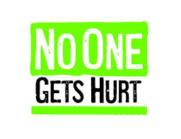 | Safety Tidbits
2-17-14 Be kind whenever possible. It is always possible. –Dalai Lama
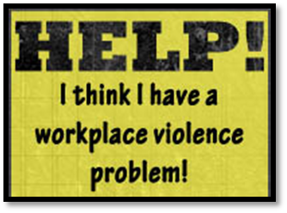  Workplace Violence Findings  • Workplace homicides & other violent acts are the 2nd leading cause of death for women at work  • For the first 10 years, an average of 558 work-related homicides occurred annually in the US  • Workplace suicides rose to an all-time high of 270 incidents in 2010  • More than a half million non-fatal assaults are reported each year  • 86% of work-related shootings were in the private sector.  • 4 out of 5 victims slain in 2008 were male, with homicides making up roughly 10% of fatal work injuries.  • Most often occur in nursing homes, social services, hospitals and late night convenient stores  • Workplace violence costs an estimated $121 billion, annually  • Non-fatal assaults result in more than 876,000 lost workdays and $16 million in lost wages    Reserves are low-Donate today!  Knock, Knock. Who's There?  Wayne!  Wayne Who?  Wayne-drops keep falling on my head… | Six Tips for Preventing Workplace Violence  Assess Your Work Environment - Critically examine all areas of your work environment, including parking lots, entryways, reception areas, work areas, and offices. Is the lighting adequate? Are there convenient escape routes? Do you have a method to summon assistance?  Pay Attention to the Warning Signs - Many people who become violent communicate their intentions in advance. Threats from customers, coworkers, or third parties should be reported immediately.  Promote Respect - The best way to prevent violence in the workplace is to foster a day-to-day attitude of respect and consideration in your work environment.  Know Your Violence Response Procedures - Violence Response Procedures are simple plans designed to minimize injury during a violent incident. These procedures should include a plan to summon assistance and move people to a safe area.  Trust Your Instincts - Don’t ignore your internal warning system. If you sense impending danger, react accordingly.  Use a Team Approach - If you are in a situation in which hostility could occur, use the “buddy system.”  Never underestimate the value of a good night’s sleep  Sleep Deprivation Can Lead to Serious Health Problems  Sleep disorders and chronic sleep loss can put you at risk for:  -Heart attack -Heart disease/Heart failure  -Stroke -High blood pressure  -Diabetes -Irregular heartbeat  According to some estimates, 90% of people with insomnia -- a sleep disorder characterized by trouble falling and staying asleep -- also have another health condition.  Sleep Loss Also Dumbs You Down  Sleep plays a critical role in thinking and learning. Lack of sleep hurts these cognitive processes in many ways. First, it impairs attention, alertness, concentration, reasoning, and problem solving. This makes it more difficult to learn efficiently.  Second, during the night, various sleep cycles play a role in “consolidating” memories in the mind. If you don’t get enough sleep, you won’t be able to remember what you learned and experienced during the day.  Heart Health Tips from the CDC  -Eat a healthy diet. Choosing healthful meal and snack options can help you avoid heart disease and its complications. Be sure to eat plenty of fresh fruits and vegetables. Eating foods low in saturated fat and cholesterol and high in fiber can help prevent high blood cholesterol. Limiting salt or sodium in your diet can also lower your blood pressure.  •Maintain a healthy weight. Being overweight or obese can increase your risk for heart disease. To determine whether your weight is in a healthy range, doctors often calculate a number called the body mass index (BMI). Doctors sometimes also use waist and hip measurements to measure a person's excess body fat.  •Exercise regularly. Physical activity can help you maintain a healthy weight and lower cholesterol and blood pressure. The Surgeon General recommends adults engage in moderate-intensity exercise for 2 hours and 30 minutes every week.
At Home, at Work, at Play – Safety Always! Keep watching out for each other!

