ENERGY AND ENVIRONMENT CABINET

Matthew G. Bevin Department for Natural Resources Charles G. Snavely
Governor Division of Mine Safety Secretary
300 Sower Boulevard
Frankfort, Kentucky 40601
Phone (502) 573-0140
Fax (502) 573-0152 John Small
Commissioner

SAFETY ALERT
(Alert – No. 2 – 2019)

Kentucky DMS – Pending Accident No.2
On Wednesday, May 22, 2019, a 48-year-old continuous miner operator with 12 years of mining experience was injured while working at an underground mine in the Harlan Branch.

The accident occurred while the victim was mining in the left crosscut. He was positioning the continuous miner’s electrical trailing cable when the corner of the coal pillar dislodged and struck him pinning him between the fallen debris and the mine floor.

The Accident Scene

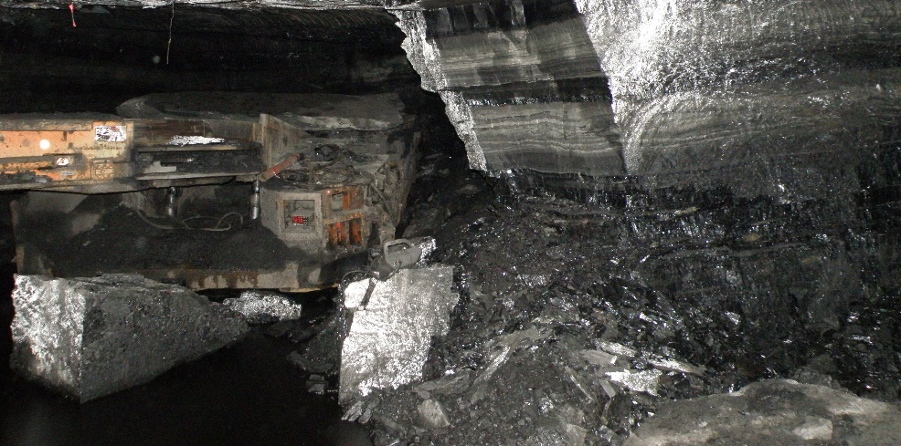

Location of the miner operator under the debris

RECOMMENDATIONS

- Thorough examinations of the roof and ribs shall be conducted prior to performing work.
- Loose ribs shall be taken down and/or adequately supported.
- Conduct thorough pre-shift and on-shift examinations of the roof, face, and ribs immediately before working or traveling in an area, and thereafter as conditions warrant.
- Use rib bolts on cycle and in a consistent pattern to provide protection against rib falls.
- Take additional safety precautions when mining heights increase to prevent development of rib hazards.

