Safety and Health Talks: Walking Safely in Winter
(Week of January 26, 2009)

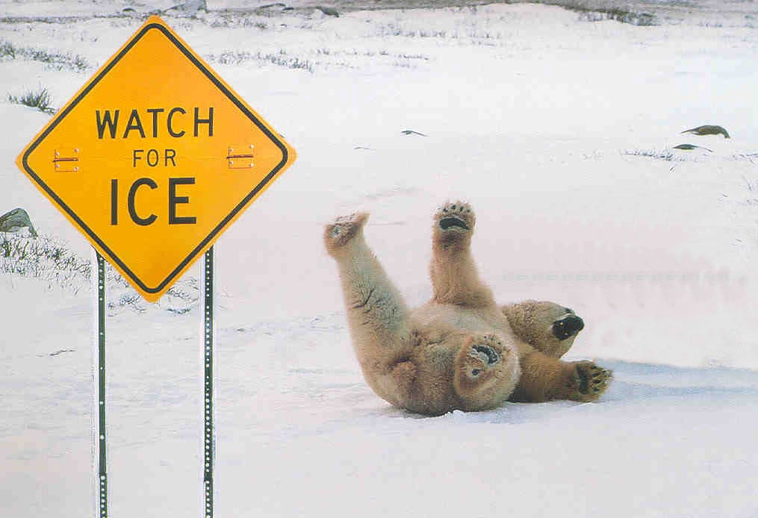

Safety Tips for Winter Walking
Winters arrive crisp and cold and the ground is covered with snow. Then, there are those beautiful days when the weather is so bad we’re given administrative leave to stay home. (Woo-hoo!)

But more often we cope with snowy weather: our people go to their offices or to their assigned mines and we often end up with injuries from falling on sidewalks, parking lots, or a mine walkway.
You can take a few simple measures to make it safer to walk outdoors in the winter. Remove snow and ice, put sand or salt on areas where people walk, and wear the right footwear. These precautions all make a big difference.
Older age groups are more likely to be admitted to hospital, with injuries serious enough to require longer stays. According to one study, over one-third of all people hospitalized after falling on ice were 60 to 79 years of age; on average they were hospitalized for 7.6 days. The elderly stay in hospital the longest after a fall on ice. The average stay for those aged 80 and older was 14.5 days.
Just one bad fall on ice can have long-term consequences. These include: chronic pain in the affected area; a disabling injury that may mean loss of independence; or fear of another fall, which discourages a healthy, active lifestyle.
Basic Precautions
At home or at work, for you or for an elderly relative, here are some practical suggestions if you’re going to stay active in the winter.
As winter approaches, outfit yourself for safe walking:
Choose a good pair of winter boots. For warmth and stability look for these features:
- well insulated and waterproof;
- thick, non-slip tread sole;
- wide, low heels; and
- light in weight.
Ice grippers on footwear can help you walk on hard packed snow and ice. But be careful! Grippers become dangerously slippery and must be removed before walking on smooth surfaces such as stone, tile and ceramic. Before buying the grippers, be sure that you are able to attach and remove them from your boots, this is best done sitting down.
Use a walking stick or cane to help with balance. Have it fitted to the right height for you. When a cane is held upside down, the end should be at wrist level. Speak to your doctor or pharmacist about how to use your cane properly.
If you’re walking along a road, help others see you by wearing bright colors or adding reflective material to your clothing.
Prevent heat loss by wearing a warm hat, scarf, and mittens or gloves. Dressing in layers may also keep you warmer.
Once the snow and ice arrive, make sure your walking surfaces are safe:
Keep entranceways and sidewalks clear of ice and snow. Report hazards on sidewalks or pathways to whoever is responsible. Don’t ignore it.
Carry a small bag of grit, sand or non clumping cat litter in your jacket pocket or handbag, to sprinkle when you are confronted with icy sidewalks, steps, bus stops, etc.
Walking on Ice
Facing an icy surface can be a paralyzing experience. Not everyone has grippers and other safety aids. So, what should you do if it’s impossible to avoid an icy patch? Believe it or not, body movements can increase your stability on an icy surface.
First, slow down and think about your next move. Keep your body as loose as possible, spread your feet to more than a foot apart to provide a base of support. This will help stabilize you as you walk.
Next, keep your knees loose and don’t let them lock. If you can, let them bend a little. This will keep your centre of gravity lower to the ground, which further stabilizes the body.
Now you are ready to take a step. Make the step small, placing your whole foot down at once. Then shift your weight very slowly to this foot and bring your other foot to meet it the same way. Keep a wide base of support.
Some people prefer to drag their feet or shuffle them. If this feels better to you, then do so. Just remember to place your whole foot on the ice at once and keep your base of support approximately one foot wide.
Of course, it’s always better to avoid tricky situations by being prepared and planning a safe route for your walk.
Who knows more about walking on ice than a penguin? Check out the following site for how your happy feet can walk more safely on ice.

http://www.boston.com/interactive/graphics/2008/20090107_ice/

