Sea Level Alarmism Unravels As Earth’s Coastlines Are Observed Expanding Since 1984
2 days ago

Charles Rotter

91 Comments
from the NoTricksZone
By Kenneth Richard on 18. November 2021

Despite sea level rise, 1984-2019 satellite data show coastlines have been globally expanding by a net +0.26 m/year.
A new study affirms what satellite data have been telling us for years: “the global coastline is prograding” (Mao et al., 2021).
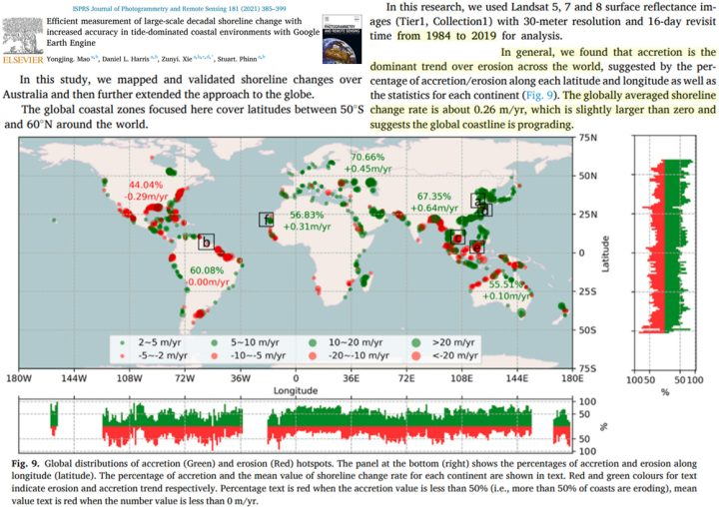Image Source: Mao et al., 2021
Growing islands, beaches, coasts “all over the world”
This isn’t the first time shoreline expansion in the era of global warming and allegedly rapid sea level rise has been documented.
A 2019 global-scale analysis of 709 islands in the Pacific and Indian Oceans revealed 89% were either stable or growing in size, and that no island larger than 10 ha (and only 1.2% of islands larger than 5 ha) had decreased in size since the 1980s (Duvat, 2019).
Likewise, the globe’s beaches been growing by 0.33 m/year since 1984 (Luijendijk et al., 2018).
In a press release for a 2016 paper on coastal land area changes from 1985 to 2015, scientists acknowledged this:
“We expected that the coast would start to retreat due to sea level rise, but the most surprising thing is that the coasts are growing all over the world“ – BBC
“Accretion is the dominant trend…across the world”
Today there are high resolution satellite images available from Google Earth clearly demarcating global-scale decadal shoreline change since the 1980s.
According to Mao and colleagues, Australia’s coasts have been growing at a rate of +0.10 m/year. Asia’s coasts have been expanding +0.64 m/year. Europe’s coasts are accreting +0.45 m/year. And the African continent has been observed expanding at a +0.31 m/year clip since 1984.
The only two continents where coasts have not been observed expanding in recent decades are South America, 0.00 m/year, and North America, -0.29 m/year.
Claims of dangerously accelerating sea level rise posing an imminent global threat to coasts have once again been challenged by real-world observational evidence.

