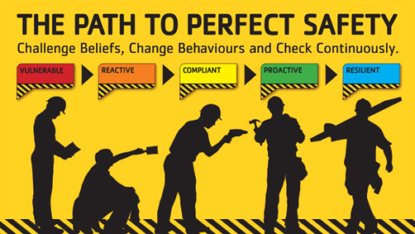 | Safety Tidbits
September 30, 2013 I refuse to believe the Sky is the limit… when there are footprints on the moon!
September is National D&A Recovery Month The goal is to:  -Promote the societal benefits of prevention, treatment, and recovery for mental and substance use disorders,  -Celebrate people in recovery,  -Laud the contributions of treatment and service providers, and  -Promotes the message that recovery in all its forms is possible. Recovery Month spreads the positive message that behavioral health is essential to overall health, that prevention works, treatment is effective and people can and do recover.    Knock Knock  Who's there?  Aida!  Aida who?  Aida lot of sweets and now I've got tummy ache!  Q: What did the hamburger name its baby? A: Patty  Life is what you make it… So, Make it GREAT! | A few Ergonomics Tips  Know the warning signs of caused by poor ergonomics & posture.  For example, if back pain is worse at certain times of day or week (such as after a long day of sitting in an office chair in front of a computer, but not during the weekends); pain that starts in the neck & moves downwards into the upper back, lower back and extremities; pain that goes away after switching positions while sitting or standing; sudden back pain that is experienced with a new job, a new office chair, or a new car; and/or back pain that comes and goes for months. Report issues immediately – before permanent damage occurs.  Get up and move. As muscles tire, slouching, slumping, and other poor postures become more likely; this puts extra pressure on the neck & back. In order to maintain a relaxed yet supported posture, change positions frequently. One way is to take a break from sitting in an office chair every half hour for two minutes in order to stretch, stand, or walk.  Keep your body in alignment while sitting & standing. Distribute body weight evenly on feet while standing. While sitting in an office chair, take advantage of the chair’s features. Sit up straight & align the ears, shoulders & hips in one vertical line. Any single position, even a good one, will be tiring. Leaning forward with a straight back can alternate with sitting back, using the back support of the office chair to ease the work of back muscles. Also be aware of & avoid unbalanced postures such as crossing legs unevenly while sitting, leaning to one side, hunching the shoulders forward or tilting the head.  September is also Fruits and Vegetables Month  Remember hearing "Eat your fruits and veggies."? It turns out Mom was right!  - Healthy diets rich in fruits and vegetables may reduce the risk of cancer and other chronic diseases.  - Fruits and vegetables provide essential vitamins and minerals, fiber, and other substances that are important for good health.  - Most fruits and vegetables are naturally low in fat and calories and are filling. http://www.cdc.gov/nutrition/everyone/fruitsvegetables/cup.html  Remember to:  --Watch out for personal safety and safety of co-workers!  --Take 5 for Safety every task, every day!  --Stop Think and Ask! Whenever you are Unsure?  THINK R.O.A.R. and take a stand for Safety!  Every employee has the…  -Right - to a safe work environment!  -Obligation - to follow applicable laws, procedures & company policy & to speak up whenever a concern is noted  -Authority - to STOP A JOB for compliance reasons/concerns!  -Responsibility - to do their part!  No time is better spent than that spent in the service of your fellow man.  -Bryant McGill
Compliance is not enough – Speak up if you see a Hazard or witness an At-risk act!

