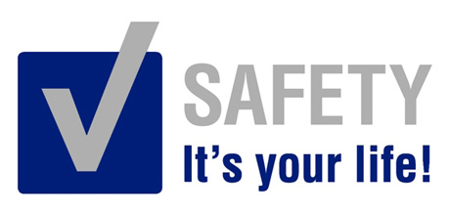 | Safety Tidbits
5-5-14 Example is not the main thing in influencing others, it is the only thing. -Albert Schweitzer
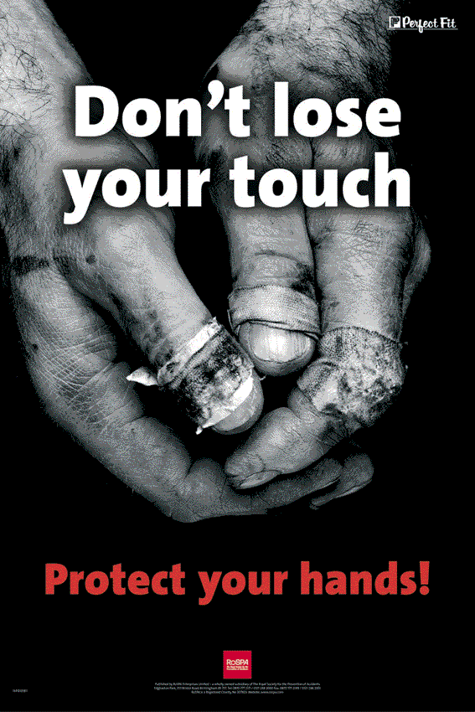  Safety is a Team Effort!  -Safety Always - Make safety a personal value rather than an afterthought!  -Communicate - Ensure that every member of the crew knows the requirements before the job is started.  -Accountability - Safety is your responsibility, should your part of the load.  -See & Act - Identify & mitigate the hazards to reduce the risk to team members.  -Think - Be careful so that you don’t create additional hazards.  -Plan - Avoid take shortcuts by always following correct procedures.  -Own it - Keep your work area clean and orderly.  -Be a Team Player - Hold each other accountable and watch out for each other.  _____________________  What do you get when you cross a hammock and a dog?  A Rocker Spaniel.  What is green and sings?  Elvis Parsley. | Hand Tools: General Safety Guidelines  • The greatest hazards posed by hand tools result from misuse and improper maintenance. Some examples:  • Using a screwdriver as a chisel may cause the tip of the screwdriver to break and fly, hitting the user or other employees.  • If a wooden handle on a tool such as a hammer or an axe is loose, splintered, or cracked, the head of the tool may fly off and strike the user or another worker.  • Using a wrench when its jaws are sprung is dangerous as it is more likely to slip.  • Impact tools such as chisels or wedges are unsafe if they have mushroomed heads which could shatter on impact, sending sharp fragments flying.  • Work with co-workers to ensure the safe condition of tools and equipment.  Ergonomics Injuries are On the RISE  Employee Awareness and Early Reporting are the most effective means of minimizing pain and reversing the damage! Report any Ergo issues to your supervisor immediately! Signs and Symptoms may include any of the following:  -Pain in the fingers, wrists, or other parts of the body: examples include a dull aching pain, a sharp stabbing pain, or even a burning sensation  -Tingling or numbness, particularly in the hands or fingers  -Swelling, inflammation, or joint stiffness  -Loss of muscle function or weakness  -Discomfort or pain in the shoulders, neck, or upper or lower back  -Extremities turning white or feeling unusually cold  -General feeling of muscle tightness, cramping, or discomfort  -Clumsiness or loss of coordination  -Range of motion loss  -Discomfort when making certain movements  EARLY INTERVENTION is the key to reducing your risk of permanent damage.  GHS Label Requirements  For all chemicals, regardless of toxicity or hazards, the product identifiers, precautionary statements, and suppliers information are all required.  • Hazard Statement: A universal phrase is assigned to hazard category; the phrase will describe how it is hazardous. (e.g., “Harmful to aquatic life”, “Harmful if swallowed”)  • Pictogram: A diamond with a red border and a symbol inside depicting a hazard class (e.g., skin irritation/corrosion).  • Precautionary Statement: A statement with the recommended precautionary steps to prevent the negative effects that can result from exposure to a chemical or product. It may also be for prevention, storage, disposal, and response.  • Product identifier: A method to identify a specific chemical or mixture usually through the use of names or numbers on the SDS or hazardous product label  • Signal Word: A word used to describe the severity associated with the hazard and alert people using the product of the potential hazard. Currently, there are two signal words: o Warning: less severe hazard o Danger: more severe hazard  • Supplier Identification: The name, address, and telephone number of the supplier of the chemical, mixture, or product must be on the GHS.
Choose a Brighter Future – Choose Safety!

