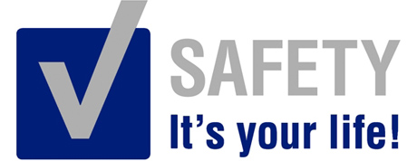 | Safety Tidbits
4-7-14 Beware of the barrenness of an overcrowded life. -Anonymous
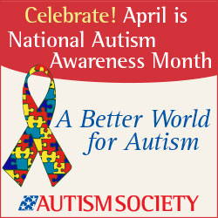  Facts About Autism  Autism Spectrum Disorder (ASD) is a developmental disability that can cause significant social, communication and behavioral challenges.  -1 in 88 children in the US has an ASD.  -Autism is the fastest growing developmental disability in the United States  -Autism effects boys 4-5 times more often than girls  -Parents who have a child with autism have a 2-8% more likely to have another child with autism  -Approximately 40% of those with autism do not speak  -Autism is a lifelong disability and those with autism live a normal life span.  -There is not a medical test to diagnose autism, nor is there a cure at this time. However, the symptoms of autism often can be greatly reduced with intensive early intervention; often leading to higher quality lives.  _______________  What did the big toe say to the little toe? Don’t look now but there’s a heel following us! | Tips for a Healthier Breakfast  The latest research tells us to eat like a king in morning, a prince at noon and a pauper in the evening. Experts claim you should have protein at every meal (ex. bacon, yogurt, milk, cheese, peanut or almond butter, fish, etc.). But you cannot live on protein alone. The problem is many cereals on the market can throw a healthy lifestyle for a loop. A few things to remember.  100% Whole Grains are Best - Look for cereals with 100% whole grains rather than made with whole grains.  Add the Fruit yourself - Buy plain cereals and add fresh fruit as fruit in cereal is generally sugar coated which adds empty calories.  Fiber is Good - Select cereals with at least 5 grams of fiber per serving  Sodium is Bad – Watch the extra salt; always choose cereals with less than 180 milligrams of sodium per serving.  The Five Absolutely Unbreakable Laws of Life by Brian Tracy  The Law of Cause and Effect: Everything happens for a reason; for every effect there is a specific cause.  The Law of Belief: Whatever you truly believe, with feeling, becomes your reality.  The Law of Expectations: Whatever you expect, with confidence, becomes your own self-fulfilling prophecy.  The Law of Attraction: You are a living magnet, and you invariably attract into your life the people, situations and circumstances that are in harmony with your dominant thoughts.  The Law of Correspondence: Your outer world tends to be a reflection of your inner world and corresponds with your dominant patterns of thinking  Motor Vehicle Crashes now the No. 1 Cause of Work-related deaths  When you drive – Just DRIVE! That phone call or TEXT can wait. Cell phone use increases risk of work-related vehicle accidents. You take a Gamble when using your phone while driving --- that could mean Betting Your Life! If it really cannot wait, if you must take the call or read the text – PULL OVER before you hurt someone else. News flash: That hands-free device doesn’t help when your mind is not on The Road!  Are you Ready?  According to the American Heart Association sudden cardiac arrest is a leading cause of death in the workplace. Surprisingly, only 12% of the employed adults in the U.S. have received training on the proper use of workplace AEDs. Having an AED in the workplace is a great start, but it is important that people know how to use the equipment properly.  Every minute of delay in care decreases the chances of survival by 10%, defibrillation needs to occur within 3-5 minutes after the onset of cardiac arrest.  Latest epidemic in the US? Tooth Decay in Children  The CDC says 42% of children ages 2-11 have had cavities in their baby teeth. 21% of those ages 6-11 have had cavities in their permanent teeth. Wake up, America!  Talk to your family dentist or search the web for tips! Teeth should last a lifetime!
Safety is about Leadership! See a deficiency – Take Ownership & Take Action!

