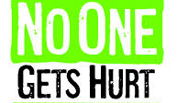 | Safety Tidbits
3-24-14 We must find time to stop and thank the people who make a difference in our lives. -JFK
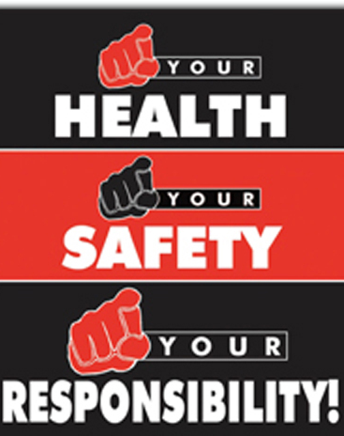  I am responsible for my own safety… pass it on!  If you notice a safety issue, Take ownership – correct it or report it to someone who can! Safety Excellence means watching out for each other! Safety Always!    If you plan to spend time working in the yard or garden remember to take exercise care.  -Bend at the knees not the waist.  -Avoid twisting while lifting  -Wear gloves & eye protection  -Use earplugs if mowing or whacking weeds  -Remember the Sunblock!  Knock, knock  Who’s there?  Goat  Goat who?  Goat to the door & find out. | A few tips for those who have Kids in the House!  Never leave children unattended near water or fire. Check bodies of water (pool or bathtub) first, when a child is missing —you can prevent a drowning by mere seconds.  -Unload and lock away firearms, and any other weapons.  -Keep medications and chemicals safely out of reach.  -Keep choking hazards (small items and small food) safely out of reach.  -Keep heavy or breakable objects safely out of reach.  -Use round-ended furniture, and avoid sharp objects and accessories.  -Secure household items - prevent tipping by securing bookcases, shelves, large TVs and other objects or appliances that could disastrously fall.  -Immediately replace any damaged, frayed, or faulty materials or appliances that could pose a hazard to an unsuspecting child.  -Cover outlets and coil extension cords when not in use  -Reduce the risk of suffocation.  --Remove access to trunks, old refrigerators, car trunks, and any other such area where children could get locked in.  --Keep beds and cribs as bare as possible—infants in particular are susceptible to suffocation.  -Block or lock the windows, stairways, and doors to prevent accidental falls or unintended wanderings by small children.  -Protect kids from plants. Plants are beautiful, infuse the air with oxygen, and decorate a room nicely. But they can be toxic if consumed. Know what plants you have, and opt for the safest ones.  Smile - Spring is upon us!  For much of the US that means rain and Spring storms. Whether you work indoors or out, there are some safety tips you should know. Below are a few quick tips for lightning storm safety:  -If you are caught outside in a thunderstorm or lightning storm with no safe shelter anywhere nearby, immediately get off elevated areas such as hills, mountain ridges or peaks.  -Get out and away from ponds, lakes and other bodies of water. Never lie on the ground or take shelter under an isolated tree. Also, never use a cliff or rocky overhang for shelter.  -Finally, stay away from objects that conduct electricity, including wire fences, power lines, etc.  Wellness Programs Pay Off  In the February 2010 issue of Health Affairs, several wellness program studies were published, revealing that medical costs fell $3.27 for every $1 spent on wellness. Furthermore, absenteeism costs fell $2.73 for every $1 spent. That is a 6:1 ROI. Wellness programs also tend to improve morale, loyalty, and engagement which can improve productivity.  If your company does not have a wellness plan – have your own. Join a fitness center or find an exercise buddy and get active. Exercise today for a healthier tomorrow… you’ll be glad you did!!!
Safety – take it with you…then it’ll be Everywhere You Want to Be!

