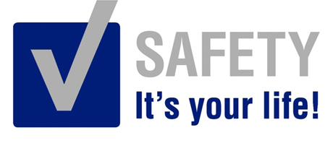 | Safety Tidbits
3-17-14 Gratitude is not only the greatest of virtues, but the parent of all others. -Cicero
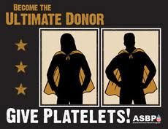  Platelet donations are different from whole blood donations?  • Donating platelets is a very safe procedure. Sterile, single-use collection kits and needles are used once, just for you, and then discarded.  • You can donate platelets up to 24 times a year compared to 6 times a year for whole blood.  • If you are blood type AB, your platelets are especially valuable to certain patient populations.  • Platelet donations take roughly 90 minutes to 2 hours.  • Platelet donors cannot have taken any aspirin or aspirin products for 48 hours before their donation.  • You feel no different from donating whole blood, and are instructed to return to your normal (not strenuous) activities.  Platelet donors are desperately needed! Many lives are saved due to those who donate – cancer & leukemia patients, open heart surgery& organ transplant patients all need platelets.  Save a life – DONATE Today!  Knock, knock  Who’s there?  Water… Water who?  Water you doing in my house? | Lift & Carry Safety Facts and Tips  Lifting and carrying are power jobs – when you lift and carry the wrong way, you can damage your back. Back injuries are the most common type of injury in the workplace, resulting in approximately 200,000 cases involving days away from work annually. Over half of these injuries are from lifting.  Back injuries may be difficult to treat and may have lengthy and expensive rehabilitation times. Tips from the National Safety Council:  -Size up the load – tip it on its side to see if you can carry it comfortably. Get help if the load is too big or bulky for one person. Check for splinters, rough or sharp edges.  -Lift it right – make sure your footing is solid. Keep your back straight, with no curving or slouching. Center your body over your feet, get a good grip on the object and pull it close to you. Pull your stomach in firmly. Lift with your legs, not your back; if you need to turn, move your feet and do not twist your back.  -Use your stomach as a low back support by pulling it in during lifting.  A strong, healthy, power back is vital to your job. It also helps you enjoy life. Take pains to avoid injuries by making it a full-time job to take care of your back!  OSHA focusing on Hazardous Workplaces in 2014  OSHA recently issued its annual inspection plan under the Site-Specific Targeting 2014 program to direct enforcement resources to workplaces where the highest rates of injuries and illnesses occur. The SST program is one of OSHA's main programmed inspection plans for high-hazard, non-construction workplaces that have 20 or more workers.  Food Allergies can be a Matter of Life and Death  Foodborne Illness causes 5,000 deaths a year. Approximately 76 million cases of foodborne illness are reported in the US annually, resulting in an average of 325,000 hospitalizations and 5,000 deaths.  Signs and symptoms of food allergies:  -Itching, rash, hives -Swelling around face and of throat  -Respiratory difficulty/ congestion -Stomach pain, vomiting, diarrhea  -Vertigo, fainting  Survival tips:  -Inform others of your allergy with a medical alert bracelet/necklace  -Carry an auto-injector device with epinephrine (adrenaline)  -Get medical help immediately  Save the children:  -Ensure school officials know about the allergy and what to do in case of a food allergy attack.  -Ensure your child understand allergens, how to read labels and stay away from certain ingredients, and what to do in an emergency.  -Prepare the child (and school) with equipment & resources (EpiPen) to react if something like that occurs, and to seek immediate medical assistance.  -Stock up with smart, safe snacks.
For a Better Tomorrow, Work Safely Today!

