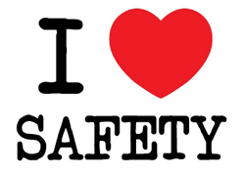 | Safety Tidbits
2-24-14 If you can dream it, you can achieve it. –Zig Ziglar
A Lack of Quality Sleep Makes You Forgetful  Trying to keep your memory sharp? Try getting plenty of sleep. In 2009, researchers determined that brain events called “sharp wave ripples” are responsible for consolidating memory. The ripples also transfer learned information from the hippocampus to the neo-cortex of the brain, where long-term memories are stored. Sharp wave ripples occur mostly during the deepest levels of sleep.  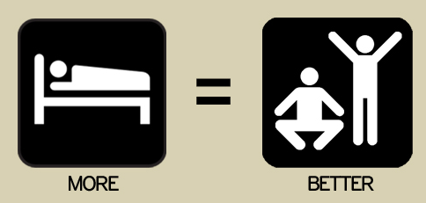  Lack of Sleep May Increase Risk of Death  In the “Whitehall II Study,” researchers looked at how sleep patterns affected the mortality of more than 10,000 British civil servants over two decades. The results showed that those who had cut their sleep from seven to five hours a night nearly doubled their risk of death from all causes. In particular, lack of sleep doubled the risk of death from cardiovascular disease.  Did you hear about the rubber-band pistol that was confiscated from a high school algebra class?  It was determined to be a weapon of math disruption! | Tips to Avoid Getting Sick  People infected with flu may be able to infect others beginning 1 day before symptoms develop and up to 5-7 days after becoming sick. That means you may be able to spread the flu to someone else before you know you are sick as well as while you are sick. Young children, those who are severely ill, and those who have severely weakened immune systems may be able to infect others even longer.  -While sick, limit contact with others as much as possible to keep from infecting them.  -Cover your nose and mouth with a tissue when you cough or sneeze. Throw the tissue after use.  -Wash your hands often with soap and water.  -Avoid touching your eyes, nose and mouth. Germs spread this way.  -Sneeze into the crook of your bent arm/elbow so the germs do not go on your hands.  -Take wipes to work and routinely clean frequently touched objects/surfaces to help remove germs.  -Try to avoid close contact with sick people.  -If you or your child gets sick with flu-like illness, CDC recommends that you (or your child) stay home from work/school for at least 24 hours after the fever is gone  Driver Safety Tips  Stay focused on defensive driving  -Keep 100% of your attention on driving at all times.  -Use defensive driving techniques and be aware of what others around you are doing and expect the unexpected.  -Don’t use a cell phone or any other electronic device while driving.  Practice safe driving tips  -Build time into your trip schedule to stop for food, rest breaks & phone calls  -Adjust your seat, mirrors and climate controls before putting the car in gear.  Prioritize car safety  •Secure cargo that may move around while the vehicle is in motion. Don’t attempt to retrieve items that fall to the floor.  -Have items needed within easy reach, such as toll fees, toll cards and garage passes.  Make the time for driving safety  -Pull over to eat or drink. It takes only a few minutes.  -Practice defensive driving & give yourself time to react. Keep a 2 second cushion between you & the car in front of you − 4 seconds if the weather is bad.  Slow down  -Speeding gives you less time to react and increases the severity of an accident.  -Speeding can result in a ticket  -Speeding reduces fuel efficiency  -Always leave yourself extra time – so you won’t be rushed  Think safety  -Always wear your seat belt and make sure everyone in the car Buckles up!  -Drive sober and drug-free  -Check headlights and tail lights routinely to ensure they are working properly.
At Home, at Work, at Play – Safety Always! Keep watching out for each other!

