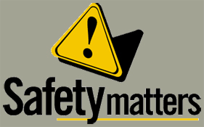 | Safety Tidbits
12-9-13 Change your thoughts and you change your world. –Norman Vincent Peale
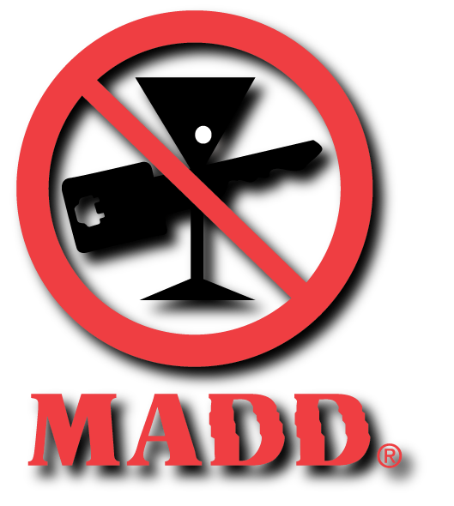  According to Mothers Against Drunk Driving (MADD), deaths from drinking and driving spike around the holidays, with alcohol being blamed for about 52% of fatal collisions on Christmas and 57% on New Year’s compared to a rate of 41% for the entire year. In addition to the more than 1,200 alcohol-related deaths that will occur on the road this holiday season, the CDC estimates that more than 25,000 people will be injured.  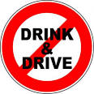  What happens when you step on an orange?  You hurt its peelings  What did the fork say to the knife?  "You're looking sharp!" | Holidays can Raise the Stress Level  Stress and depression can ruin your holidays and hurt your health. Try to prevent stress and depression, especially if the holidays have taken an emotional toll on you in the past. Here are a few tips that may help…  Acknowledge your feelings. If someone close to you has recently died or you can't be with loved ones, realize that it's normal to feel sadness and grief.  Reach out. If you feel lonely or isolated, seek out community, religious or other social events. They can offer support and companionship. Volunteering your time to help others also is a good way to lift your spirits and broaden your friendships.  Be realistic. The holidays don't need to be perfect. As families change and grow, traditions and rituals change as well. Be open to creating new ones.  Set aside differences. Try to accept family members and friends as they are, even if they don't live up to all of your expectations. Set aside grievances until a more appropriate time for discussion. It will ease the stress of others too.  Stick to a budget. Before you go shopping, decide how much money you can afford to spend. Then stick to your budget. Don't try to buy happiness with an avalanche of gifts. Perhaps this is the year to start a family gift exchange.  Plan ahead. Set aside specific days for shopping, baking, visiting friends and other activities. Minimize last minute activities to reduce the likelihood of accidents.  Learn to say no. Saying yes when you should say no can leave you feeling resentful and overwhelmed. Don’t take on more than you can handle.  Maintain healthy habits. Eat a healthy snack before holiday parties so that you don't go overboard on sweets, drinks, etc. Get plenty of sleep and stay physically activity.  Take a breather. Make some time for yourself. A little time alone can be very refreshing. If you need to, take a walk to clear your mind, slow your breathing and restore inner calm.  OSHA Tools Available  To help lower the chances of chemical exposure, OSHA offers employers Web-based tools and resources. These resources include a toolkit to locate safer alternatives to the chemicals employers currently use, as well as annotated Permissible Exposure Limits (PEL) tables. https://www.osha.gov/dsg/annotated-pels/  A Few Forklift Facts  Forklifts are involved in nearly 35,000 serious injuries every year. What you should know:.  OSHA requires eyewash stations if battery-operated forklifts are in use. Businesses must provide an eyewash station and, in some cases, an emergency shower within a 10-second reach of battery-operated forklifts. This helps minimize the impact of injuries caused by battery acid splashes or dust and flying debris.  OSHA requires training for forklift operators. Each operator must complete formal training that includes classroom instruction, trainer demonstrations, exercises and practical evaluation of individual operator performance.  25% of workplace transport-related accidents involve a forklift. Given the frequency of forklift accidents, workers should understand what steps to take in the event of an accident, such as how to call emergency personnel for help.  Forklift batteries can emit toxic gases while charging. While charging, batteries release oxygen and hydrogen gases, which can be highly explosive if the workplace is not properly ventilated. Source: FSM Magazine
If we fail to get Compliance right, little else matters!

