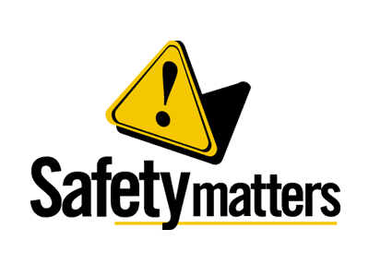 | Safety Tidbits
11-4-13 Don't find fault, find a remedy. -Henry Ford
Pancreatic Cancer Month  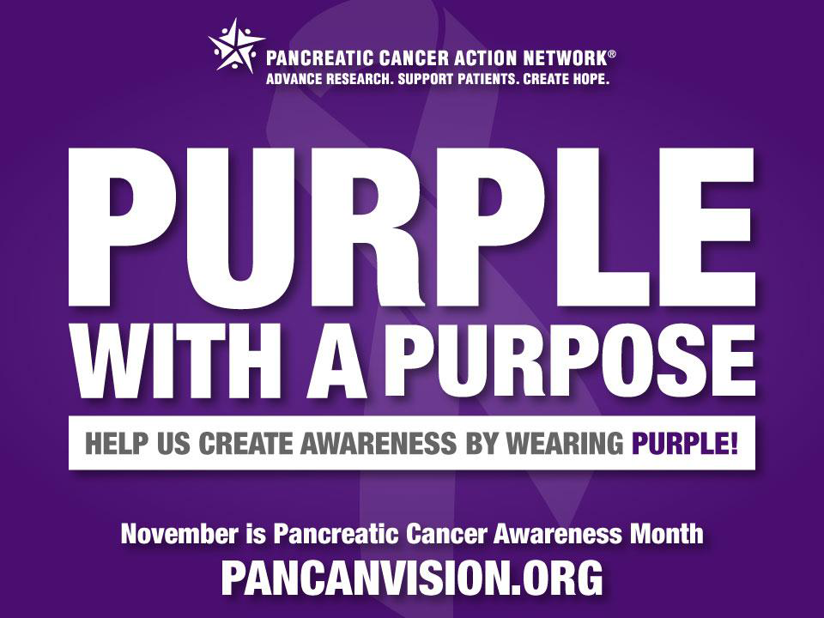  Pancreatic Cancer is one of the most challenging diseases physicians face today because it responds poorly to treatment and quickly spreads to surrounding organs. This is why November is so important: to raise awareness around early detection and prevention as well as highlight current research to help find a cure for pancreatic cancer.  Nearly 44,000 people are diagnosed with pancreatic cancer every year.  ________________  When everything seems to be going against you, remember that the airplane takes off against the wind, not with it. -Henry Ford  Why do bananas have to put on sunscreen before they go to the beach?  Because they might peel!  Knock Knock  Who's there?  Aesop!  Aesop who?  Aesop I saw a puddy cat! | Know the FACTS  Pancreatic cancer is the only one of the top 24 cancer killers that still has a five-year survival rate in the single digits  • In 2012, about 37,390 deaths are estimated to occur from pancreatic cancer  • Pancreatic cancer is the fourth most common cause of cancer death in men and women in the U.S.  • The risk for developing pancreatic cancer triples if a person's mother, father or a sibling had the disease  Suicide Deaths on the Rise  Suicide rates among middle-aged Americans have risen sharply in the past decade, prompting concern that a generation of baby boomers who have faced years of economic worry and easy access to prescription painkillers may be particularly vulnerable to self-inflicted harm. 2009 was the first year suicides surpassed motor vehicle deaths in the U.S. Many companies have Employee Assistance Programs which offer a wide array of help from grieve counseling to financial assistance. Check with your HR Department to find out more. Most suicidal individuals give warning signs or signals of their intentions.  Suicide Prevention - The best way to prevent suicide is to recognize these warning signs and know how to respond if you spot them.  -Talk of suicide, dying, or self-harm, such as "I wish I hadn't been born," "If I see you again..." and "I'd be better off dead."  -Withdrawing from friends and family. Increasing social isolation.  -Unusual focus on death or dying. Writing poems or stories about death.  Seeking access to guns, pills, or other items that could be used to attempt suicide.  Five Lessons for Life  - Life isn't fair, but it's still good.  - When in doubt, just take the next small step.  - Life is too short to waste time hating anyone.  - Don't take yourself so seriously. No one else does.  - You don't have to win every argument. Agree to disagree.  What should I do to prepare for this flu season?  CDC recommends a yearly flu vaccine for everyone 6 months of age and older as the first and most important step in protecting against this serious disease. While there are many different flu viruses, the flu vaccine is designed to protect against the three main flu strains that research indicates will cause the most illness during the flu season. Getting the flu vaccine as soon as it becomes available each year is always a good idea, and the protection you get from vaccination will last throughout the flu season.  In addition, you can take everyday preventive steps like staying away from sick people and washing your hands to reduce the spread of germs. If you are sick with flu, stay home from work or school to prevent spreading influenza to others.  When will flu activity begin and when will it peak?  The timing of flu is very unpredictable and varies from season to season. Activity most commonly peaks in the U.S. in January or February. However, seasonal flu activity can begin as early as October and continue to occur as late as May.
Safety begins with Compliance – don’t let it end with YOU!

