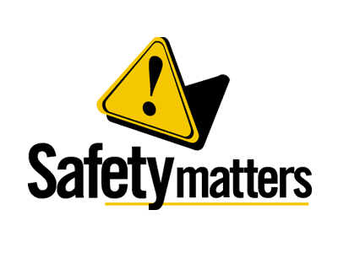 | Safety Tidbits
11-11-13 If the wind will not serve, take to the oars. –Latin Proverb
Support WWP!  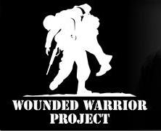  Wounded Warrior Project  (WWP) is a veterans’ service organization that offers a variety of programs, service and events for wounded veterans of the military actions following the events of 9/11/2001. It operates as a nonprofit 501(C)(3) organization with a mission to "honor and empower Wounded Warriors" of the United States Armed Forces, as well as provide services and programs for the family members of its registered "alumni," as its registered veterans are called.  The greatest casualty is being forgotten.TM  What do you need to have a really good art collection? …Monet!  What do you get when you mix an actor and a fragrance? Smell Gibson | Veteran’s Day  We didn't always celebrate "Veterans Day." The holiday got its start as "Armisitice Day" on Nov. 11, 1919 as a way to honor the end of The Great War — what we now call World War I. The day marked the first anniversary of the end of the war. Congress voted to make it an annual observance in 1926, and it was upgraded to a national holiday in 1938. In 1954, President Dwight D. Eisenhower signed the bill changing the day's name to Veterans Day. There are many parades planned across the U.S. this weekend – attend one in honor of the fine men and women who serve and have served.  The Status of HIV Prevention in the United States  The science is clear: HIV prevention can and does save lives. Scores of scientific studies have identified effective prevention interventions for numerous populations, and it is estimated that prevention efforts have averted more than 350,000* HIV infections in the United States to date. In addition to the lives saved from HIV, it is estimated that more than $125 billion in medical costs alone have been averted.  But the HIV crisis in America is far from over. CDC’s latest estimates suggest that more than 56,000 Americans (one person every 9 ½ minutes) become infected each year, and that more than one million people in this country are now living with HIV. Far too many Americans remain at risk for HIV, especially African Americans, Latinos, and gay and bisexual men of all races. CDC estimates that roughly 1 in 5 people infected with HIV in the United States is unaware of his or her infection and may be unknowingly transmitting the virus to others.  The heavy burden of HIV in the United States is neither inevitable nor acceptable. It is possible to end the U.S. epidemic, but such an achievement will require that we dramatically expand access to proven HIV prevention programs, make tough choices about directing available resources, and effectively integrate new HIV prevention approaches into existing programs.  Suicide Deaths among Veterans is Extremely High  (CNN) – Every day, 22 veterans take their own lives (that’s more than double the rate of civilians). That's a suicide every 65 minutes. As shocking as the number is, it may actually be higher. Leon Panetta, the former defense secretary, called the suicide rate among service members an epidemic.  The figure, released by the Department of Veterans Affairs in February, is based on the agency's own data and numbers reported by 21 states from 1999 through 2011. Those states represent about 40% of the U.S. population. The other states, including the two largest (California and Texas) and the fifth-largest (Illinois), did not make data available.  The Centers for Disease Control and Prevention (CDC) collects data about mortality in the U.S., including deaths by suicide. In 2010 (the most recent year for which data are available), 38,364 suicides were reported, making suicide the 10th leading cause of death for Americans. In that year, someone in the country died by suicide every 13.7 minutes.
Safety begins with Compliance – don’t let it end with YOU!

