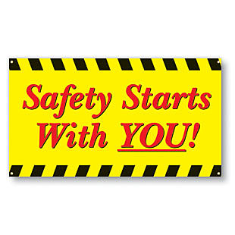 | Safety Tidbits
October 7, 2013 Every strike brings me closer to the next home run. –Babe Ruth
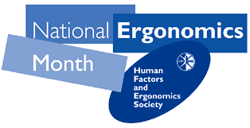  Increase your  Ergonomics Awareness.  Being aware of posture and ergonomics at work, at home, and at play is a vital step towards instilling good posture & ergonomic techniques. This includes making conscious connections between episodes of back pain and specific situations where poor posture or ergonomics may be the root cause of the pain.  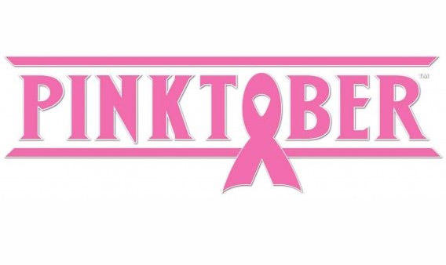  In October, countries around the globe will celebrate Breast Cancer Awareness Month with 31 days spotlighting prevention, education, and finding a cure.  While most people are aware of breast cancer, many forget to take the steps to have a plan to detect the disease in its early stages and encourage others to do the same. Learn more at:  http://www.nationalbreastcancer.org/breast-cancer-awareness-month  Q: What gets wetter the more it dries? A: A towel.  Q: What did the frog order at the diner?  A: French flies and a Diet Croak! | Be aware of the Ergonomic Hazards of your job  In 2010, overexertion in lifting was the leading cause (38%) of the work-related musculoskeletal disorders among construction workers. Other leading causes of nonfatal injuries include: being struck by an object, falls to lower level, and overexertion in lifting. However, the rates have dropped steadily since 1992.  Some Ergo Tips:  -Use posture-friendly props when sitting. Supportive ergonomic “props” can help to take the strain and load off of the spine. Ergonomic office chairs or chairs with an adjustable back support can be used at work. Footrests, portable lumbar back supports, or even a towel or small pillow can be used while sitting in an office chair and while driving. Using purses, bags, and backpacks that are designed to minimize back strain can also influence good posture. Proper corrective eyewear, positioning computer screens to your natural, resting eye position can also help to avoid leaning or straining the neck with the head tilted forward.  Exercise to help prevent injury. Regular exercise such as walking, swimming, or bicycling will help the body stay aerobically conditioned, while specific strengthening exercises will help the muscles surrounding the back to stay strong. These benefits of exercise promote good posture, which will, in turn, further help to condition muscles and prevent injury. There are also specific exercises that will help maintain good posture. In particular, a balance of trunk strength with back muscles about 30% stronger than abdominal muscles is essential to help support the upper body and maintain good posture.  The Truth – it may be time to Change your Lifestyle  According to the recent CPWR study, in 2010, 71% of construction workers were either overweight or obese, 30% had hypertension, and 8% had diabetes. Among those aged 55 years and older, 56% had hypertension, 18% had diabetes, and 15% had heart disease. This study focused only on construction workers, but the numbers line up with what we have been hearing for the past couple of years… approximately 1/3 of the US population is overweight, ~1/3 is obese and the last third is about average. Some of us need to look in the mirror and consider a lifestyle change – and that is one of the reasons I now walk 3-4 miles per day.  How about some Good News  Workplace Safety efforts continue to make a positive impact: The fatality rate in construction declined to 9.4 per 100,000 full-time equivalent workers (FTEs) in 2010, dropping by 34% since 1992. The rate of nonfatal injuries and illnesses resulting in days away from work was 1.5 per 100 FTEs in 2010, while it was 5.3 per 100 FTEs in 1992. Source: CPWR 2013 Study  Some Shocking News from the 2013 NSC Expo  More than 1 in 3 deaths among 16-20 year olds is caused by a crash. That’s not all - in 2002, 9,200 people died in crashes involving drivers aged 15-20. By 2011, that number was almost cut in half to 4,767… that bad news is motor vehicle crashes are still the Number One Cause of Death among U.S. Teens!!!  Source: National Center for Highway Safety
Compliance is not enough! – Speak up if you see a Hazard or witness an At-risk act!

