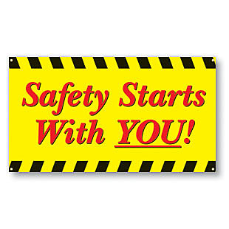 |  | Safety Tidbits
October 28, 2013 How do you know if a man needs encouragement? If he is breathing. –S. Truett Cathy
!  11/11/13 is Veteran’s Day    An early but heartfelt thank you to all of our veterans and active military persons. God Bless you and yours… and to our Viet Nam veterans – welcome home!  ----------------------  Nearly 2.5 million people suffer eye injuries each year in the United States, and  nearly one million people have lost some degree of vision as a result. Most could  have been prevented with protective eyewear.  Did you know…5 to 10 workers are injured or killed daily in this country, due to arc flash accidents, according to statistics compiled by Chicago-based Capshell, Inc.  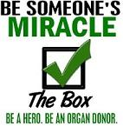  Why are ghosts bad liars?  Because you can see right through them  What is a witch’s favorite part in school?  Spelling, of course! | October is Eye Injury Prevention Month - It can happen in the blink of an eye. You may have no time to react. That's why it's so important to protect your eyes from harm.  According to the American Academy of Ophthalmology, an estimated 90% of eye injuries are preventable with the use of proper safety eyewear. If the eye is injured, seek emergency medical help immediately.  Dangers at Home - When we think of eye protection, we tend to think of the workplace. We often forget that even at home, we might find ourselves dealing with similar threats to our eyes. Dangerous chemicals that could burn or splash the eyes aren’t restricted to chemical laboratories. They’re also in our garages and under our kitchen sinks. Debris and other air-borne irritants are present at home, too, whether one is doing a home construction project or working in the yard. The debris from a lawnmower or “weed-wacker,” for example, can be moving at high speeds and provide no time to react. Some sports also put the eyes at risk of injury from foreign objects moving at high speeds.  Effective Eyewear - The best ways to prevent injury to the eye is to always wear the appropriate eye protection. The BLS reports that approximately 60% of workers injured were either not wearing eye protection at the time of the accident or wearing the wrong kind of eye protection for the job.  Vision is a gift. Make the extra effort to protect it.  Remember - October is Fire Prevention Month  According to the National Fire Protection Association (NFPA), a home structure fire was reported every 87 seconds in 2009. Is your family prepared for a fire emergency?  - Do you have a home fire escape plan? Have you changed smoke-alarm batteries within the last year?  - Do you know the main reasons for fires starting in the home? Get more information at the NFPA’s website NFPA.  Seven Tips to Help You Become a Friendlier Person  1. Don’t criticize, condemn or complain.  2. Give honest, sincere appreciation.  3. Arouse in the other person an eager want.  4. Become genuinely interested in other people.  5. Smile more – it’ll make you feel better.  6. Be a good listener. Encourage others to talk about themselves.  7. Make the other person feel important - and do it sincerely.  From the for what it’s worth department  - A cat has 32 muscles in each ear.  - A crocodile cannot stick out its tongue.  - A dragonfly has a life span of 24 hours.  - A goldfish has a memory span of three seconds.  - A "jiffy" is an actual unit of time for 1/100th of a second.  - A shark is the only fish that can blink with both eyes.  - Al Capone's business card said he was a used furniture dealer.
Compliance is not enough! – Speak up if you see a Hazard or witness an At-risk act!

