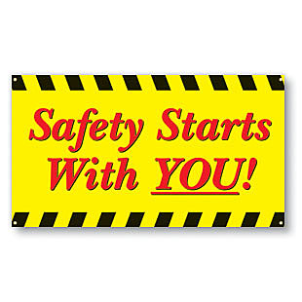 | Safety Tidbits
October 21, 2013 Dream big and dare to fail. –Norman Vaughan
!  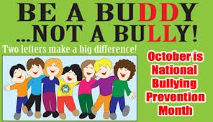  ITASCA, IL -- Forty-five people die every day because of prescription painkillers -- more than heroin and cocaine combined. To stem the tide, the National Safety Council examined and rated each state's effectiveness in addressing this epidemic.  States are at varying levels of response in addressing this public health threat. Where does your state rank?  Find out in the newly released NSC report titled Prescription Nation: Addressing America's Prescription Drug Abuse Epidemic  The International Labor Organization estimates that every 15 seconds worldwide, a worker loses his or her life due to a work-related injury or illness, and more than 650 workers died in the United States last year as a result of falls, slips or other missteps in the workplace, according the U.S. Bureau of Labor Statistics.  Knock Knock  Who's there? Aladdin!  Aladdin who?  Aladdin the street wants a word with you! | October is Breast Cancer Awareness Month According to the Cancer Center of University of Michigan, 80 to 85 percent of women with breast cancer have no family history of the disease. That being said, it is important to get a yearly mammogram, regardless of family history.  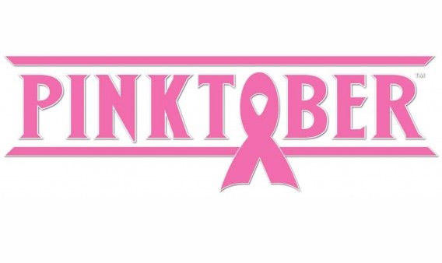  Facts about Bullying  Over 3.2 million students are victims of bullying each year.  25% of teachers see nothing wrong with bullying and will only intervene 4% of the time.  Approximately 160,000 teens skip school every day because of bullying.  1 in 7 students in grades K-12 is either a bully or a victim of bullying.  56% of students have personally witnessed some type of bullying at school.  Over two-thirds of students believe that schools respond poorly to bullying, with a high percentage of students believing that adult help is infrequent and ineffective.  71% of students report incidents of bullying as a problem at their school.  90% of 4th through 8th graders report being victims of bullying.  1 out 10 students drop out of school because of repeated bullying.  Harassment & bullying have been linked to 75% of school-shooting incidents.  Physical bullying increases in elementary school, peaks in middle school and declines in high school. Verbal abuse, on the other hand, remains constant.  Think Fire Safety  October is Fire Prevention Month and the history of National Fire Prevention Week has its roots in the Great Chicago Fire, which occurred on October 9, 1871. In two days the Great Chicago Fire destroyed half of the existing city, leaving 300 dead and 100,000 homeless.  According to the latest NFPA research, cooking is the leading cause of home fires. Two of every five home fires begin in the kitchen—more than any other place in the home. Cooking fires are also the leading cause of home fire-related injuries.  Below are safety tips that the County of Santa Barbara and the local emergency managers would like to emphasize:  - Stay in the kitchen when you are frying, grilling, broiling, or boiling food  - If you must leave the room, even for a short period of time, turn off the stove  - When you are simmering, baking, or roasting food, check it regularly, stay in the home, and use a timer to remind you  - If you have young children, use the stove’s back burners whenever possible  - Keep children and pets at least three (3) feet away from the stove  - When you cook, wear clothing with tight-fitting sleeves  - Keep potholders, oven mitts, wooden utensils, paper and plastic bags, towels, and anything else that can burn, away from your stovetop  - Clean up food and grease from burners and stovetops
Compliance is not enough! – Speak up if you see a Hazard or witness an At-risk act!

