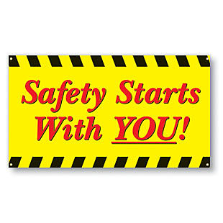 | Safety Tidbits
October 14, 2013 To handle yourself, use your head; to handle others, use your heart. -Eleanor Roosevelt
!  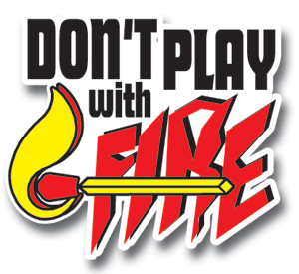  Smoke Alarms –Are still a very important addition to your home. Install a smoke alarm on every level of your home and test it month.  Prevent Electrical Fires  Don’t overload circuits or extension cords. Cords & wires should never be placed under rugs or in high traffic areas. Avoid loose electrical connections by checking the fit of the plug in the wall outlet. If the plug loosely fits, inspect the outlet right away. A poor connection between the plug & the outlet can cause overheating and can start a fire in minutes.  Keep Plugs Safe  Unplug appliances when not in use. Follow manufacturer’s safety precautions and use your senses to spot any potential disasters. If a plug is overheating, smells strange, shorts out or sparks – the appliance should be shut off immediately, then replaced or repaired.  ______________________________  Knock Knock  Who's there?  Adolf!  Adolf who?  Adolf ball hit me in the mouth!  ________________________________  Why did the new golfer carry take off his socks - he worried he might get a hole in one. | 5 Kid Halloween Costume Safety Tips  Make it fit. The outfit & shoes should fit the child appropriately so they can move around safely. Avoid anything too long which could cause them to trip.  Make it flame-retardant. Avoid anything too loose which could be a fire hazard! Don’t buy a costume unless it’s labeled “flame-retardant” which means the material won’t burn.  Make it visible. Choose a light-colored costume, attach something reflective to their costume or allow them to wear or carry a flashlight or glow stick to increase visibility to motorists.  Make it easy to see out of. Choose non-toxic face paint and makeup when possible instead of masks which can obstruct a child’s vision.  Make it breathable. Make sure wigs and beards don’t cover your kids’ eyes, noses or mouths making it difficult to breathe or see.  Lastly don’t forget to make it fun and safe. You and your kids will enjoy the holiday even more knowing they are avoiding preventable injuries thanks to a safe costume! Source: Dayton Children's Hospital  More Ergonomics Tips  Wear supportive footwear when standing. Avoid wearing high-heeled shoes, which can affect the body’s center of gravity and change the alignment of the entire body, negatively affecting back support and posture. A rubber mat on the floor can improve comfort.  Maintain good posture when in motion. Walking, lifting heavy materials, and typing are all moving activities that require attention to posture. It is important to maintain good posture even while moving to avoid injury. Back injuries are especially common while twisting and/or lifting and often occur because of awkward movement and control of the upper body weight alone.  Check your work space. Take the time to get it right. Undue strain will be placed on the structures of the spine unless the office chair, desk, keyboard, and computer screen, etc. are correctly positioned.  Avoid overprotecting posture. Remember that it is important to maintain an overall relaxed posture to avoid restricting movements by clenching muscles and adopting an unnatural, stiff posture. For individuals who already have some back pain, it is a natural tendency to try to limit movements to avoid the potential pain associated with movement. However, unless there is a fracture or other serious problem, the structures in the spine are designed for movement and any limitation in motion over a long period of time creates more pain and a downward cycle of less motion and more pain, etc.  Workplace Safety  Today we still see around 10 work-related fatalities and nearly 14,000 injuries every day in U.S. workplaces. And that’s not all – we also see approximately 427,000 occupational illnesses and 53,000 related fatalities. We have come a long way, but there is much work to be done… Safety begins or ends with you! Please Speak Up when you see an At-risk act or an Unsafe Condition. You can make a difference! We all can make a difference, if we choose to get involved!
Compliance is not enough! – Speak up if you see a Hazard or witness an At-risk act!

