MSHA Safety and Health Talks: Driving in Rain
(Week of June 23, 2008)

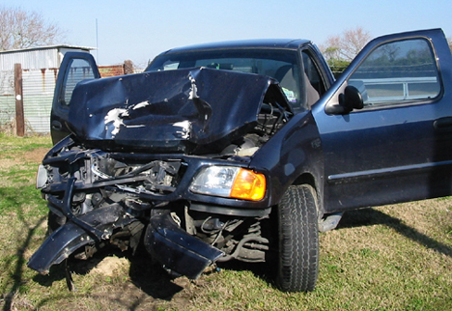

Driving in the Rain
The law says if it’s raining, you must turn on your headlights—not just your parking lights—to make your car easier for others to see.

Skidding and Hydroplaning
What’s the difference between skidding and hydroplaning when driving? A skid is when your car slides and—unless you drive at NASCAR events—the car is ordinarily not under control.

Hydroplaning happens when the water in front of your tires builds up faster than your car’s weight can push it away. The water pressure causes your car to rise up and slide on a thin layer of water between your tires and the road. At this point, your car can be virtually out of contact with the road.

How to Prevent Skidding
- Drive slowly and carefully, especially on curves;
- Do not brake hard or lock the wheels which can increase the risk of a skid;
- Maintain mild pressure on the brake pedal.

When Your Car Skids
- Remain calm;
- Ease your foot off the gas, carefully steer in the direction you want the car to go, and slowly put your foot on the brakes;
- For cars without anti-lock brakes, avoid using the brakes. This procedure, known as “steering into the skid” will bring the back end of your car in line with the front.

How to Prevent Hydroplaning
- Keep your tires properly inflated;
- Make sure they have good treads;
- Slow down when roads are wet and stay away from puddles.

When Your Car Hydroplanes
- Do not brake or turn suddenly;
- Ease your foot off the gas until the car slows and you can feel the road again;
- If you need to brake, do it gently with light pumping actions. If your car has anti-lock brakes, brake normally.

